IoT-Based Smart Pill Dispenser with Real-Time Notification System

A Capstone
Presented to the Faculty of
College of Computing Studies
Don Honorio Ventura State University
In Partial Fulfillment

of the Requirements for the Degree
Bachelor of Science in Information Technology

by:

Hipolito, Francine T.
Macapagal, Angel L.
Macasu, Rome John Y.
Pangilinan, Lester S.
Soriano, Michaela Joy

April 2026

CHAPTER I

The Problem and It’s Background
Introduction
Medication adherence plays a vital role in ensuring the effectiveness of medical treatments and improving patient health outcomes. However, medication non-adherence remains a significant challenge worldwide, particularly among elderly individuals and patients with chronic illnesses such as hypertension, diabetes, and cardiovascular diseases. Many patients struggle to follow prescribed medication schedules due to forgetfulness, complex treatment regimens, busy lifestyles, cognitive limitations, or lack of proper monitoring. Failure to take medications on time may lead to disease progression, increased hospitalization rates, higher healthcare costs, and reduced quality of life.
Traditional methods of medication management, including handwritten schedules, alarm clocks, and conventional pill organizers, have been widely used to assist patients in remembering their medications. Although these methods provide basic support, they often rely heavily on the patient's memory and active participation. Furthermore, caregivers and family members may not always be available to monitor medication intake, making it difficult to ensure adherence, particularly for elderly patients living independently. As a result, there is a growing need for more intelligent and automated solutions that can assist patients in managing their medications accurately and consistently.
Recent advancements in the Internet of Things (IoT) have transformed healthcare by enabling the development of smart systems capable of automation, remote monitoring, and real-time communication. IoT technologies allow devices to collect, process, and transmit data through internet connectivity, providing users and caregivers with timely information and system updates. In healthcare applications, IoT has been utilized in patient monitoring, health tracking, medical alert systems, and medication management solutions. These innovations have demonstrated the potential to improve healthcare delivery, enhance patient safety, and increase treatment compliance.
The integration of IoT technology into medication management systems offers a practical approach to addressing medication non-adherence. Smart pill dispensers can automate medication dispensing based on predefined schedules while simultaneously providing notifications and monitoring functions. By reducing reliance on memory and manual supervision, these systems help patients follow their prescribed treatment plans more effectively. In addition, real-time notifications and cloud-based monitoring allow caregivers to stay informed about medication-related activities even when they are physically distant from the patient.
This study proposes the development of an IoT-Based Smart Pill Dispenser with a Real-Time Notification System designed to improve medication adherence through automation and remote monitoring. The system utilizes an ESP32 microcontroller, Real-Time Clock (RTC) module, servo motor, infrared sensor, Firebase cloud database, GSM communication, and a mobile application to automate medication dispensing, monitor pill removal, store medication records, and send real-time notifications to users and caregivers. The infrared sensor is used to detect whether the dispensed medication has been removed from the dispenser, while the mobile application provides access to medication schedules, dispensing logs, and adherence records.
Through the integration of hardware and software technologies, the proposed system aims to provide a reliable, efficient, and user-friendly medication management solution. By automating dispensing operations and enabling real-time monitoring and notifications, the study seeks to reduce missed doses, improve medication adherence, and support patients who require regular medication schedules. Ultimately, the system contributes to the advancement of smart healthcare technologies and promotes better health outcomes through improved medication management practices.

Purpose and Description
The main goal of this capstone project is to modernize medication management in selected households in Poblacion Candaba, Pampanga by replacing manual reminders and human-dependent monitoring with an automated and reliable system. The project will be developed in response to the recurring problem of medication non-adherence, which is commonly experienced by elderly individuals and patients with chronic conditions who require strict and timely medication intake. Traditional methods such as verbal reminders, handwritten schedules, and pill organizers will often fail to ensure consistency because they rely heavily on memory, the availability of caregivers, and continuous supervision, which may lead to missed doses and health complications.

The IoT-Based Smart Pill Dispenser with a Real-Time Notification System will be developed as an integrated hardware and software solution that will automate medication dispensing and improve adherence monitoring. It will use an ESP32 microcontroller as the central unit, along with an RTC module for accurate scheduling, servo motors for controlled dispensing across multiple compartments, and sensors to detect whether medication has been taken. A camera module will also be integrated to provide visual monitoring and additional confirmation of medication intake. As an IoT-based system, it will connect to a cloud database through Firebase and will be paired with a mobile application developed in Flutter, allowing users to set schedules, monitor intake, and receive real-time updates. The system will also send SMS and push notifications to the patient and to family and caregivers when a dose is missed or not confirmed, ensuring timely intervention even without constant internet access.

Objectives of the Study
The primary objective of this capstone project is to design and develop an IoT-Based Smart Pill Dispenser with a real-time notification and monitoring system. The study aims to automate medication dispensing, verify dosage intake, and provide real-time remote monitoring through a mobile application to improve medication adherence among patients in selected households in Poblacion Candaba, Pampanga.

Specific Objectives
- To design and develop an automated pill dispensing mechanism integrated with an ESP32 microcontroller and Real-Time Clock (RTC) module for accurate medication scheduling across multiple compartments.
- To develop a mobile application that will enable real-time remote monitoring of medication schedules, dispensing logs, and system status for patients, family, and caregivers.
- To implement sensor-based dosage verification to confirm correct pill dispensing and detect whether the medication has been removed within a defined time period.
- To integrate real-time push notifications and SMS alerts to notify users regarding missed doses, dispensing events, emergency medication requests, and low medicine supply.
- To incorporate system features such as camera-based monitoring, emergency medication dispensing button, and remote device management through the mobile application.
- To evaluate the functionality, usability, reliability, performance efficiency, and notification accuracy of the Smart Pill Dispenser system through system testing and user evaluation.

Significance of the Study
The capstone project will develop an IoT-Based Smart Pill Dispenser with a real-time notification and monitoring system intended for selected households in Poblacion Candaba, Pampanga. By integrating automated medication dispensing, sensor-based intake confirmation, camera-assisted monitoring, and mobile application connectivity, the study will address common challenges in medication management such as missed doses, incorrect intake, and lack of continuous supervision. The system will provide real-time alerts and remote monitoring, offering a more reliable and organized approach to household medication management.

For Patients - The system will benefit patients by ensuring that medications will be dispensed accurately and on schedule based on the programmed settings. It will help reduce missed doses and improve medication adherence, particularly for elderly individuals and patients with chronic conditions who require strict medication routines. The inclusion of automated dispensing, sensor-based confirmation, camera monitoring, and emergency medication access will provide additional safety and support in daily medication intake.

For Family and Caregivers - The system will assist family members and caregivers by providing real-time notifications and updates regarding medication schedules, dispensing events, and missed doses. Through the mobile application, they will be able to monitor patient adherence even when they are not physically present. This will reduce the need for constant supervision while improving communication and response time in cases of missed or unconfirmed medication intake.

For Healthcare Professionals - The cloud-based adherence logs provided healthcare providers with objective, time-stamped data on patient medication behavior. This information could support clinical decision-making, therapy adjustments, and patient consultations, improving the overall quality of chronic disease management.

For Future Researchers - The study will serve as a reference for future research in the field of IoT-based healthcare systems. It will provide a foundation for further development of smart medication management technologies, including enhancements such as advanced sensor integration, artificial intelligence for adherence prediction, and improved remote healthcare monitoring systems.

Scope and Delimitation
To provide a clear understanding of the capstone project parameters, this section will define the specific goals and coverage of the IoT-Based Smart Pill Dispenser system and identify the deliberate boundaries and restrictions set by the researchers in terms of its design, features, and implementation.

Scope
The IoT-Based Smart Pill Dispenser project is designed specifically for selected households in Poblacion Candaba, Pampanga. This capstone project focuses on developing an automated medication management system that utilizes an ESP32 microcontroller and Real-Time Clock (RTC) module for accurate time-based scheduling. The system covers a dispensing mechanism consisting of 10 medication compartments powered by servo motors for controlled release of medicines. It also includes sensor-based monitoring to detect medication removal and confirm intake, along with a camera module for visual monitoring of patient interaction with the device. Additionally, the system integrates a Flutter-based mobile application that allows users such as patients, family, and caregivers to set medication schedules, monitor dispensing activities, and receive real-time notifications. The system is connected to Firebase for cloud storage and synchronization and includes SMS-based alerts for critical notifications in low-connectivity situations. It also covers features such as emergency medication dispensing, stock level monitoring, refill alerts, and system diagnostics to support reliable home-based medication management.

Delimitation
While the IoT-Based Smart Pill Dispenser project aimed to improve medication management in selected households in Poblacion Candaba, Pampanga, several limitations were acknowledged. First, the system will be limited to solid oral medications such as tablets and capsules and will not support liquid medicines, injections, or other forms of medication. Second, the study will focus strictly on home-based environments and will not be implemented or evaluated in hospital or clinical settings. Third, accessibility will be restricted to Android devices only, as the mobile application will not support iOS platforms. Additionally, the system will depend on stable internet connectivity for real-time monitoring, cloud synchronization, and notifications, although SMS alerts will serve as a backup in cases of poor connection. Finally, the evaluation will be limited to selected households in Poblacion Candaba, Pampanga with a restricted number of respondents and testing duration, which may affect the generalizability of the results.

Definition of Terms
To provide a clear understanding of this capstone project, the following terms are defined both conceptually and operationally:

Automated Pill Dispensing - The process of releasing medication from a device without human intervention at a pre-programmed time. In this study, it refers to the servo motor-driven mechanism that rotates a compartmentalized pill holder to release the correct medication at the scheduled time.

ESP32 Microcontroller - A low-cost, dual-core microcontroller with built-in Wi-Fi and Bluetooth capabilities. In this project, it serves as the central processing unit of the Smart Pill Dispenser, coordinating all hardware inputs, outputs, and internet communications.

Firebase - A cloud platform developed by Google that provides real-time database management, secure authentication, and push notification services. In this system, Firebase Firestore stores all medication logs and adherence records, while Firebase Cloud Messaging sends real-time alerts to the mobile app.

Flutter - An open-source UI development framework created by Google for building natively compiled applications across multiple platforms from a single codebase. In this project, it was used to develop the Android mobile application for patient and caregiver monitoring.

GSM Module (SIM800L) - A global system for mobile communications module that enables devices to send and receive SMS messages via a cellular network. In this system, it serves as a backup alert mechanism to send missed-dose notifications to registered users without requiring internet connectivity.

Internet of Things (IoT) - A network of interconnected physical devices embedded with sensors and software that exchange data over the internet. Operationally, this refers to the connected architecture linking the Smart Pill Dispenser hardware, Firebase cloud, and the mobile application.

Medication Adherence - The degree to which a patient follows a prescribed medication regimen, including taking the correct dose at the correct time. In this study, adherence is measured by the system through dispensing logs and pill removal confirmation.

Real-Time Clock (RTC) - A hardware module that keeps accurate track of current time and date, independently of the main microcontroller. The DS3231 RTC in this project ensures that medication schedules remain accurate even when the device loses internet connectivity.

Servo Motor - An electromechanical actuator that uses feedback control to achieve precise angular positioning. In this system, it physically drives the rotation of the pill compartment carousel to dispense the correct medication compartment at the scheduled time.

Conceptual Framework
The conceptual framework of this study is based on the Input-Process-Output (IPO) model, which illustrates how the system transforms gathered resources into a functional IoT-Based Smart Pill Dispenser with Real-Time Notification System.

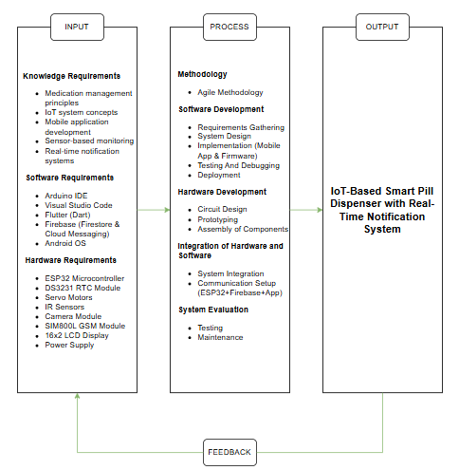
Figure 1.0 Conceptual Framework of Smart Pill Dispenser

This conceptual framework of this capstone project, as illustrated in Figure 1.0, follows the Input-Process-Output (IPO) model, which presents the systematic transformation of resources into a functional IoT-based solution. The Input phase includes the essential knowledge, software tools, and hardware components required for the development of the Smart Pill Dispenser, such as IoT concepts, mobile application technologies, and microcontroller-based devices. These inputs are processed through an Agile-based development approach, covering system design, hardware and software development, integration, and testing to ensure proper functionality and reliability. The Process phase ensures that all components work cohesively, enabling accurate medication dispensing, real-time monitoring, and notification features. The Output of the framework is the IoT-Based Smart Pill Dispenser with Real-Time Notification System, designed to improve medication adherence and support patients, caregivers, and families. Lastly, the framework incorporates a Feedback loop, which allows continuous system evaluation and refinement based on testing results and user responses, ensuring the system’s effectiveness, reliability, and long-term usability.

CHAPTER II

Review of Related Literature and Studies
This chapter presented a comprehensive review of related literature and studies that support the development of the IoT-Based Smart Pill Dispenser with Real-Time Notification System. It provided an overview of existing research and relevant theories, thereby establishing a solid foundation for understanding the context of the study.

Related Literature

Foreign Literature
IoT-Based Smart Medication Reminder and Dispensing Machine Based on Internet of Things
The study conducted by Chandana et al. (2022), presents the design and development of a medicine reminder and dispensing machine integrated within the healthcare system. This system was proposed during the pandemic to minimize direct interaction between healthcare workers and patients, thereby reducing the risk of infection. The device is capable of storing medication doses for an entire week and dispensing them at scheduled times. It also records medication intake data using an SD card for future reference by medical professionals. Additionally, the system is beneficial for home use, particularly for elderly patients who may forget to take their medications on time. The inclusion of scheduled reminders related to food intake and exercise further enhances medication effectiveness, as certain drugs require specific timing in relation to meals.
This research is highly relevant to the Smart Pill Dispenser proposed, due to the need for adherence and proper usage of an IoT-based medicine delivery system. With capabilities of scheduled drug delivery, dispensing of the correct amount of medicine, and the usage of local or cloud-based systems for storage, these solutions can create a more practical and useful health system. These solutions may aid in creating a pill dispenser that is easy to use, and helps patients take their medications consistently.
The current solution does lack some features however. Chandana et al. (2022) created a system that does not include whether the user actually takes the pill once dispensed, but rather stops after it has been delivered. The proposed Smart Pill Dispenser adds to this system by incorporating a refined verification process, which not only releases the medication, but confirms ingestion.
IoT-Based Real-Time Medicine Reminder and Dispenser for Elderly Patients
People who follow a routine medication face a challenge when taking these medicines at regular intervals. It is observed that most older citizens face these problems if they have no one to take care of them. These people are not that smart to set reminders or alarms on their smartphones to remind them of their medication routines. A device such as an IoT-based Real-Time Medicine Reminder and Dispenser Robot can help these individuals. This device will have a reminder for each medicine the user might take by four methods, it will have a speaker that will call out the name of the medicine, a Display that shall show the name of the medicine, a dispenser system that will dispense the right medicine and a mobile notification will be send to the user's phone (SS Sadi et al., 2024).
Though there are benefits when applying various reminder function in one automatically pill dispenser, the system has no mechanism to confirm whether the patient has already ingested the medication after it had been administered. Similarly, to our Smart Pill Dispenser, all the methods have a combination of sound and visual alerts as well as mobile reminders which can improve adherence. Also, it incorporates an automated dispenser so that the medicines dispensed could be as accurate as possible, lessening any chance of human error, that can be integrated to our system and could potentially help out in medication dispensing and accurate medicine dispensing to avoid any form of mistake.
Despite the advantages of the system on incorporating different reminder methods with an automated dispenser, it does not contain any kind of function that can confirm that the patient did consume the medicine even though it has been dispensed to him already. This may cause an inaccurate information as it can dispense the medicine to the user but not necessarily take by the patient. The Smart Pill Dispenser overcomes this problem by using a sensor to detect that the medicine was already taken by the patient.
Smart Medication Management Using IoT-Based Pill Dispenser and Smart Cup
In today's fast-paced environment, medication errors present a pressing challenge, especially among vulnerable populations such as the elderly and individuals with cognitive or mental health conditions. The study of Peddisetti et al. (2024) introduced an IoT-based medication management system composed of a Smart Pill Dispenser, Smart Cup, and an Android application for real-time notifications. The Smart Pill Dispenser, powered by an Arduino Nano RP2040 microcontroller, ensures accurate and timely dispensing of medication, while the Smart Cup utilizes accelerometers, gyroscopes, and ultrasonic sensors to verify actual medication intake. These devices are interconnected through Bluetooth Low Energy (BLE), enabling real-time data sharing and monitoring of medication adherence.
The system prioritizes the use of sensor-based verification in combination with automated dispensing to ensure compliance and avoid human errors. Through a smart device, it is established that in conjunction with several IoT enabled device a much more reliable system could be devised which monitors the consumption and provides feedback in real time. The patient/caregiver can make use of an application which can keep a track on the progress of medication in real time.
This can provide huge advantage in our S Smart Pill Dispenser, as the use of sensor-based verification in supplement with automatic dispensing as identified is a clear indicator of a greater degree of accuracy and reliability of our proposed system in medication management. This system uses multiple networked devices including Smart cup to check for actual medication consumption. But their device may require a separate component in the package and can increase maintenance and overall complexity compared to our Smart Pill Dispenser.
Smart Pill Dispensers and IoT: Advancements in Medication Administration
Smart pill dispensers have transformed medication delivery using Internet of Things (IoT) technology. Smart pill dispensers and their seamless interaction with IoT devices have improved medication administration. These novel methods increase medication adherence, error reduction, and patient outcomes. It includes sensors and connections for remote monitoring and control. Real-time data sharing with IoT allows healthcare practitioners to monitor adherence and intervene as needed. Smart pill dispensers use face recognition and biometric verification to ensure medicine is given to the right person. Patients and doctors get notifications for missing doses or wrong medicine. The system can be connected to the IoT and stored in the cloud. Improved medicine distribution and real-time tracking maintenance. Healthcare delivery improves patient outcomes for enhanced adherence and fewer medication mistakes. Hospital readmissions and adverse events may be reduced by drug adherence (Tiwari & Raman, 2024).
In the paper by Tiwari & Raman (2024) it was examined how the Internet of Things technology could assist medication management through smart pill dispensers. It points out that IoT supported medical devices have the capacity to change the conventional system of delivering medicines through using the combination of sensor based systems, the internet and cloud based technologies to remotely control and monitor system real-time. This allows healthcare professionals to remotely monitor patients 'medication adherence and system performance through transmission of data. There is also automated indication of inappropriate ingestion and misses. Further, the system uses biometrics and face detection to ascertain that the correct medication is administered to the correct patient. The paper is pertinent to the present study because it demonstrates the improvement of medication adherence and patient care using IoT based systems. It shows the importance of cloud integration, real time monitoring and automated indications for better reliability and reduction of medication errors. The main problem found by the paper is the use of biometrics and facial detection to integrate high security systems which is not cost efficient and also it is very complex to use, so our Smart Pill Dispenser takes an easier route of considering sensor integration for verification only which would be cost-efficient and user-friendly for clinical and domestic use.
IoT-Based Smart Medicine Dispenser to Control and Supervise Medication Intake
This paper presents a system consisting of a smart medicine dispenser of solid medications (pills, capsules, …) and a mobile application for its configuration and management. The main idea is to offer a solution to help people (especially vulnerable ones) to avoid incorrect medication intakes. In this regard, the smart dispenser delivers the required medication if two conditions are met: (1) it is the scheduled time for a medication intake, and (2) the person who removes the medication from the dispenser (patient or caregiver) can be identified and is authorized to do so. Person identification and authorization is performed through facial recognition by the dispenser and through a username and a password by the mobile application. Moreover, the system reminds the users whenever a medication intake should take place through mobile notifications and lights and sounds emitted by the dispenser. The system development has been guided by a Test-Driven Development Methodology for Internet of Things (IoT)-based Systems to promote its quality and reliability (Guerrero-Ulloa et al., 2020).
The study proposes an IoT-based smart medicine dispensing system that focuses on controlled and monitored medicine dispensation. The study addresses the inclusion of security features such as user validation through facial recognition, medicine dispensing reminder through mobile notification and continuous monitoring of medicine usage. This approach proves how the technology of IoT could be incorporated to develop controlled, secured and monitored medicine dispensing.
This study is relevant to the present research in that it addresses how to implement authentication and monitoring features in a smart medicine dispenser to achieve secure accessibility and better patient compliance with medicine administration. The usage of IoT-based tracking and mobile notification emphasizes the significance of securely managed and timely administered medicine that helps to build up a dependable medicine dispenser.
The study has a limit since it addresses only the authentication and access control rather than including other extended functionalities such as monitoring by caregiver, alert system or sensors for checking the real medicine consumption. On the contrary, the present Smart Pill Dispenser not only includes the features of authentication and access control but also adds on features such as real-time caregiver monitoring, alert system and sensors for checking the real medicine dispensing, making it a far more complete, practical and dependable medicine dispenser.
Development of a Pill Dispenser: System Requirements and Product Architecture
The study by Lima et al. (2022), focuses on the growing elderly population worldwide, which has created an increasing need to develop products that support daily living activities and promote independence in the domestic environment. This study is part of the second phase of an investigation project aimed at creating a device that stores and dispenses pills automatically with the integration of a virtual assistant. In this phase, the objective was to define the system requirements and product architecture of the device based on state-of-the-art research, user experiences, and a previously defined business model. As a result, the study identified user needs and translated them into specific device requirements, which contributed to defining the product architecture. This includes a diagram of the system electronics and a basic representation of the device, which supports the conception and development of the pill dispenser system.
Compared to this study, our Smart Pill Dispenser focuses on the implementation of a functional IoT-based medication dispensing system rather than only defining system requirements and product architecture. The study by Lima et al. (2022) emphasizes the design phase of a pill dispenser system, where user needs, system requirements, and product architecture are identified and translated into conceptual designs, including system electronics diagrams and basic device representations. It primarily focuses on planning and developing the structure of the device to support elderly independence in medication management. In contrast, our Smart Pill Dispenser moves beyond the design and conceptual stage by implementing a working system that automates medication dispensing and supports practical usage in real-world scenarios. As a result, while both studies aim to support elderly users in medication management, the referenced study focuses on system design and architecture development, whereas our system focuses on full implementation and operational functionality.

A Systematic Review on Pill and Medication Dispensers from a Human-Centered Perspective
The study by Lgargioni et al. (2024), highlights that medication adherence represents a critical challenge in healthcare, and pill and medication dispensers have gained increasing attention as potential solutions to promote adherence and improve patient outcomes. Following the PRISMA (Preferred Reporting Items for Systematic reviews and Meta-Analyses) methodology, the study conducted a systematic literature review on papers indexed in Scopus and PubMed that present solutions for pill or medication dispensers. Given the importance of user acceptance for these solutions, the research questions of the survey are driven by a human-centered perspective. The study provides an overview of different dispenser solutions by classifying them according to their stage of development. It then analyzes each solution considering its hardware and software architecture. Furthermore, it reviews the characteristics of user interfaces designed for interacting with pill and medication dispensers and examines the involvement of different types of users in dispenser management. Based on this analysis, the study draws findings and indications for future research intended to provide insights for healthcare professionals, researchers, and designers interested in developing and using pill and medication dispensers.
Our Smart Pill Dispenser system differs from the described study because the emphasis of the described study is to comprehensively review and analyze various existing technologies through a wide systematic review, not to develop and deploy the actual, functional, IoT-based pill dispenser. The work by Lgargioni et al. (2024) is primarily an examination of pill and medicine dispensers from a human aspect in the form of a literature review based on the PRISMA methodology to group current systems by its development phase and assess their hardware and software structures and user interfaces, and places particular attention to user acceptance and the different kinds of users involved in medicine taking and has conclusions and suggestions for further research and development of new systems. In comparison, Our Smart Pill Dispenser system is devoted to building a functional, operational system that directly automates taking pills. In so, the mentioned system, by having performed an inclusive evaluation and review of existent systems, will be able to contribute toward more robust medication dispensers of the future, but our system contributes to this field by building and deploying an IoT-based one.
A Review on Dispenser Mechanism of Medicine Dispenser
The study by Kini et al. (2021), highlights that in the modern age it is difficult for family members to be available all the time to support the aged, and in many societies most families are nuclear. Caring for the aged is of serious concern in developing countries. Sometimes despite their best effort, the aged fail to remember to take their medication on time. There are issues concerning seniors' ability to remember to take and handle their medicine on their own. Automatic medicine dispenser is one approach as a solution to this problem. It dispenses medicines on prescribed time with notifying the caretaker. There are various medicine dispensers with same functionality and IoT but different dispenser mechanism and design. The design and mechanism vary with the type and size of medicine. The main concern is dispenser design as the medicines are in various shapes and sizes. Hence an optimal dispensing mechanism for storing and dispensing all types of medicines is required. In this paper, a detailed review of dispensing mechanism of the Automatic Medicine Dispensers and its design is presented.
In comparison to this study, our Smart Pill Dispenser primary focus is on the actual construction and operation of an actual working IoT-based medicine dispensing device instead of the evaluation and examination of various kinds of medicine dispenser mechanism and designs. The study of Kini et al. (2021) is basically the elaboration study on various existing automatic medicine dispenser mechanisms and designs, where it discusses the requirement to develop an efficient dispenser system that is capable to hold and handle different forms and sizes of medicine in correct manner, and emphasizes various design aspect and issues. But in case of our Smart Pill Dispenser, the aim is to design and construct an IoT based smart medicine dispensing device that can automatically dispense medicines for user and hence in comparison, where the former involves exhaustive review study on dispenser mechanism, our system is an actual construction of automatic medicine dispensing device with the focus of ensuring its real-time application and usage.
Improving Medication Adherence in Elderly Patients Through IoMT-Enabled Smart Pill Dispensers: A Narrative Review
The study by Razizatunnisa et al. (2025), highlights that non-adherence to medications represents a major complication among elderly patients, with serious consequences on health outcomes and healthcare costs. The study explains that the emergence of Internet of Medical Things (IoMT)-enabled dispensers provides a promising solution to these issues through real-time monitoring, automated personal reminders, and caregiver interfacing. These devices address common barriers to medication adherence by improving patient and caregiver experience. The review aimed to evaluate the contribution of IoMT-enabled dispensers in improving medication compliance among elderly patients, using evidence from Scopus, PubMed, and the Cochrane Library. Findings suggest high adherence rates, reduced missed doses, and improved satisfaction among both patients and caregivers, attributed to real-time personalized reminders, tailored interventions, and integration with healthcare systems. However, the study also identifies limitations such as poor internet connectivity, data privacy concerns, and financial constraints. It further suggests future improvements through AI integration, policy support, and educational programs to enhance accessibility and performance of such systems.
Unlike this particular study, our Smart Pill Dispenser primarily addresses on the real development and application of a working IoT-based smart pill dispenser as opposed to reviewing and summarizing existing IoMT-based systems. A narrative review presented by Razizatunnisa et al. (2025) aims to review the role of IoMT-based smart pill dispensers in promoting adherence to medication for the elderly by taking evidence from three database of Scopus, PubMed, and the Cochrane Library. This study asserts that such systems improve medication adherence via its capability for remote monitoring, automated alarms, and caregiver alert system which leads to better medication adherence, a lower rate of missed doses and higher satisfaction from the patients and caregivers, although some challenges for these devices which are internet connection instability, privacy of patient data, and expense are discussed, with a conclusion and future improvement suggested involving implementation of AI, support policies, and education. In comparison, the development of Smart Pill Dispenser is targeted at establishing a tangible and operating IoT-based system for automated medication dispenser. Thus while the above referenced study offers a complete evaluation of IoMT-based pill dispenser and its efficacy, our system contributes on the creation of an operating solution for real-time medication adherence improvement.
Developing a Smart Pill Dispenser to Support Aging Individuals
The study by Viana et al. (2024), entitled Developing a Smart Pill Dispenser to Support Aging Individuals, explains that as a person ages, there is a tendency for the progressive degeneration of the body, which usually manifests as a loss of motor, cognitive and sensory abilities. This introduces new challenges to the independent accomplishment of previously routine tasks. Through the analysis of this issue, the authors identify that the adherence to complex medication regimes might pose a particularly difficult challenge for elderly patients, whose limitations can introduce the risk of ineffective treatments and health hazards by the wrongful taking of medicine. The solution proposed is the development of an automatic pill dispenser, designed to counteract the adverse effects of aging and enable the elderly to retain a degree of autonomy in their daily care, or support family and professional caretakers. This chapter follows the project’s development through the identification and analysis of the challenges faced by elderly individuals; a comparative study of the options currently available to support them in the identified issue; the proposal of a solution; and concluding with the construction of a preliminary prototype.
Compared to this study, our Smart Pill Dispenser also targets the needs of elderly to assist them taking medication but the approach is more inclined toward a functional IoT based application to dispense medication and keep track of adherence in real-time. The paper in Viana et al. (2024) puts more emphasis on the conceptualization of a smart pill dispenser system which aims to overcome the issues posed by age related cognitive and physical deterioration. The user issues, analysis and comparison of other devices along with the development of an initial prototype were discussed in this study, while our Smart Pill Dispenser focuses on the development and operation of a fully working IoT based automated device for reliable, timely and efficient pill dispensing.

Local Literature
SmartMed: An IoT-Enabled Pill Dispensing and Monitoring System for Medication Adherence of AFib Patients
A study introduces an IoT-enabled smart medication system designed for patients with atrial fibrillation (AFib), a condition that requires strict and continuous medication adherence to prevent serious complications such as stroke and thromboembolic events. The SmartMed system integrates automated medication scheduling, real-time dose verification, and caregiver support through a mobile application. It utilizes an ESP32 microcontroller, ultrasonic sensors for pill retrieval detection, and cloud-based synchronization via Firebase to ensure real-time communication between the device and mobile platforms. The system also supports remote emergency dispensing by caregivers and provides real-time alerts to ensure proper medication intake and monitoring. Testing results demonstrated a 100% adherence rate and high usability, showing strong effectiveness in medication management for AFib patients (Maaño et al., 2025).
This application presents the application of IoT to smart medicine management by enabling automatic dispensing of medication and simultaneous monitoring and sensors for validation of intake. Mobile applications and cloud applications would provide remote monitoring of patients by care providers and physicians as well as timely notifications and notifications when needed to provide a quick response during emergencies. This demonstrates the way that systems enabled by the IoT technology would provide better medication safety, accuracy, and compliance via intelligent communication networks and ongoing supervision. This study complements the proposed Smart Pill Dispenser in its demonstration of the importance of combining automatic medication dispensing with both real-time tracking and sensor verification for medication intake. The use of a mobile application and cloud-based system for remote monitoring of patients would enable a better overview of compliance for care providers and enable a rapid response during emergencies. The latter would provide a means for increasing medication compliance and system safety in ways applicable to this system design. Nonetheless, its features require reliable internet access due to real-time cloud synchronization and mobile communication for proper functioning. An integrated emergency dispensing function and continuous cloud-based monitoring can also lead to higher costs and increased system complexity. In comparison to the described limitation, the proposed Smart Pill Dispenser is designed as a more economical and practical system by omitting some of the more sophisticated system features while providing basic necessities like medication dispensing, sensor verification, and alerts.
MediMinder: A Smart Device for Medication Adherence
The study presents a smart medication adherence device designed to address medication non-adherence, which remains a major public health concern, particularly among individuals with chronic non-communicable diseases (NCDs) in low-resource settings such as the Philippines. The system integrates key features such as medication reminders, real-time monitoring, and storage components to support proper medication intake. Grounded in ISO 9241-210 and ISO/IEC 25010 standards, the device was evaluated using a quantitative prototyping approach involving healthcare professionals, technical experts, and regular medication users. Results showed consistently high ratings in functional suitability (M = 4.58), performance efficiency (M = 4.63), usability (M = 4.47), and reliability (M = 4.35), indicating that the system is effective, acceptable, and user-friendly for medication management. The study further emphasizes that MediMinder provides a practical and scalable solution for improving medication adherence, with recommendations for future enhancements such as improved alarm customization, caregiver integration, portability, and stronger connectivity features (Aquino et al., 2025).
In relation to this, our Smart Pill Dispenser is the advancement of MediMinder through additional advancements in medication control by making it more centralized. The MediMinder provides the reminder, monitoring and storage functions but our system attempts to gain better reliability by including the dispensing as part of the systems functions along with the real time monitoring and alarm functions. Such a function would be the improvement upon one of the inherent weaknesses in current systems which is the fact that there is no controlled dispensing; instead it is left to the reminders system and patient compliance. Adding a dispensing feature would not only provide a reminder but also adds the physical medication becoming available to the patient, hence not just providing a reminder but adding to the patient receiving the medication. Our Smart Pill Dispenser, therefore builds upon the functionality provided by current IoT-based medication systems by giving a more complete, automatic and reliable system.
Optimizing Medication Adherence with Time Pill Dispenser: A Research Project
This study explains that time-based pill dispensers are effective in improving medication adherence among patients with chronic diseases such as hypertension and diabetes. It highlights that many patients experience difficulties in following prescribed medication schedules due to forgetfulness, complex prescriptions, and lack of proper reminders, which often lead to missed doses and poor health outcomes. The study emphasizes that time-based pill dispenser systems, which use scheduled alerts and dispensing mechanisms, help guide patients in taking their medication consistently and correctly, thereby improving adherence and supporting better disease management (Optimizing Medication Adherence with Time Pill Dispenser: A Research Project, n.d.).
This study is important as it illustrates that reminder systems based on technologies are effective for solving non-compliance problem among patients. It suggests that a well-structured reminder system (like a pill dispenser) is required to help patients take medicines in a systematic manner. These results are related to design of our Smart Pill Dispenser, as we attempt to improve medicine compliance using a technology-based reminder and dispenser system.
This study, on the other hand, primarily uses time-based reminders and simple dispensing but it fails to incorporate comprehensive additional features like a remote patient monitoring system or caregiver notifications. In response to the study limitation, our Smart Pill Dispenser uses automatic dispensing, remote monitoring, alerts to improve the system more effectively and systematically.
Smart Pill Dispenser for Elderly Care
A notable issue in elderly healthcare is that not all individuals have caregivers, and even those who do may still experience difficulties in medication adherence. This situation may result from various factors such as financial constraints that limit access to consistent caregiving support, or the inability of family members to provide continuous assistance. In some cases, caregivers themselves may also forget medication schedules or be uncertain about correct dosages, revealing gaps in the current caregiving system and highlighting the need for technological support in medication management (Gorospe, 2022). Ensuring timely medication intake is essential as it improves treatment effectiveness, supports faster recovery, and enhances overall health outcomes (Santos & Almonte, 2020). In addition, smart medication systems are increasingly explored as a way to address these challenges, particularly for elderly individuals who manage multiple medications. These systems aim to reduce caregiver burden while promoting independence and improving medication compliance (Villanueva & Santos, 2023).
Addressing these issues, a research reports on an automatic smart pill dispenser created for elderly and disabled in Philippines. The system includes an automated drug dispensing capability with a voice prompt and light notification, making the system useful for taking prescribed medication accurately and at the correct dosage. The system directly targets key problems faced by the users such as lack of medication compliance, limited caregiver accessibility, medication regimen management, and dependency of patients and independence from caregivers (St. Paul University Study, 2024).
This research has great relevance with the present research since it has successfully established that the usage of a smart dispensing system can enhance medication compliance in the local elderly care facilities. The study showed that, a combination of an automated dispensing system and medication reminders is efficient for the patients' memory and correct dosage. The present study is parallel to the goals of the Smart Pill Dispenser, in which medication compliance is a priority through technology solutions.
However, the present smart pill dispenser does not include IoT-integrated functions such as real-time remote monitoring and multiple notification channel systems. The smart pill dispenser includes automated dispensing only and basic reminder function; The present Smart Pill Dispenser proposes a fully functional IoT based automated smart pill dispenser with real time monitoring and alert notifications to help users manage medication taking correctly.
Automatic Pill Dispenser with SMS Notification
This study explains that an automatic pill dispenser with SMS notification was developed to address medication non-adherence among Filipino patients. According to the study of Sibbaluca, n.d., the system uses a microcontroller and a real-time clock (RTC) module to automate the scheduling and dispensing of medication, while SMS alerts are sent to both patients and caregivers to remind them of the correct intake time. The research emphasizes that medication non-adherence is a persistent problem in the Philippines, and integrating automated dispensing with mobile communication technology can significantly improve adherence and ensure timely medication intake.
This study was important as it demonstrated that using an auto-dispenser and SMS reminder is possible for motivating medication compliance in this local setting. Alert the caregiver by SMS provides better control over the patient which can contribute to the system's objective of ensuring medication adherence to patients by applying convenient and accessible technology.
However, this system utilizes merely SMS reminder and manual automated dispenser and does not exploit full potential of modern capabilities that can be integrated by IoT devices such as real time monitoring, mobile application interface and cloud monitoring and tracking. Thus, comparing with our research, the Smart Pill Dispenser developed in this paper is an advancement, by integrating automatic dispenser, real time monitoring, multi-channel alert methods in one interface, providing a more holistic solution.
Factors associated with medication adherence of hypertensive patients in the Philippines: a systematic review
The study on medication adherence among Filipino hypertensive patients highlights that hypertension remains a leading cause of mortality in the Philippines, with a prevalence rate of 28% and a low control rate of 20%. Despite the effectiveness of pharmacologic treatment, medication adherence is reported to be as low as 66%. The review identified various factors influencing adherence, including healthcare system-related factors such as patient-health provider relationships and access to services, socioeconomic factors such as age, education, and employment status, patient-related factors such as health literacy and awareness, therapy-related factors such as inconsistent drug schedules, and condition-related factors such as illness perception. The study concludes that since healthcare system-related factors are modifiable, they can be targeted for interventions to improve medication adherence among Filipino hypertensive patients.
This research is relevant to our Smart Pill Dispenser as our proposed system directly addresses one of the main problem discussed-patients’ low medication adherence caused by forgotten drugs, low health literacy, or unstable taking intervals of medicines. Our device dispenses drugs and gives reminders on time, reducing the dependence of patient on his/her memory and making the interval of medication taking regular. Though the study focuses more on the factors inbehavioral, social and health system aspects that are affecting medication adherence, our system is intended to be a technological solution to solve it.
Utilization of Artificial Intelligence in Reducing the Incidence of Medication Error: A Bibliometric Analysis
The study by Dino et al. (2025, highlights that medication errors (MEs) represent a significant challenge in healthcare, compromising patient safety and contributing to adverse outcomes. The study emphasizes that Artificial Intelligence (AI) has emerged as a promising tool to address this issue by enhancing medication management processes and decision support systems. Using bibliometric analysis based on data from the Scopus database, the study identified 184 relevant articles and analyzed them using VOS Viewer software to examine citations, keyword relationships, and research networks. The results revealed a steady increase in publications since 1991, peaking in 2023, with key themes such as “medication error,” “artificial intelligence,” and “patient safety.” Clustering analysis further identified major themes related to the “6Rs” in medication administration (right patient, right dose, right time, right assessment, right route, and right drug), highlighting AI’s role in reducing medication errors. The study concludes that empirical research on AI is essential and that its application in healthcare shows strong potential in improving medication safety and reducing errors, especially in clinical settings.
To differentiate from the stated research, our Smart Pill Dispenser concentrates on a real-life, IoT-based system for medication administration instead of conducting a bibliometric and research trends evaluation using AI in the field of studies. Dino et al. (2025) illustrates the usage of Artificial Intelligence for decreasing medication error through the analysis of the published researches in order to define significant research trends on patient safety, decision support system and the "6R's" of administration of medication. This research also emphasizes how Artificial Intelligence can be used in the health-care system through data-driven analysis and clinical decision support. Our Smart Pill Dispenser is a ready hardware that makes sure the users, especially the aged patients, can have medication in right time and the right dose. Moreover, while Dino et al. (2025) concentrates on using Artificial Intelligence for analyzing healthcare data and on improving medication error reduction measures, our study makes emphasis on the automation of medication administration as an easy-to-use solution that benefits to patient's adherence and actual medication delivery. Both of them address on decreasing medication error and improving its safety in different directions.

Related Studies
Foreign Studies
IoT-Based Smart Medicine Dispenser with Real-Time Alerts and Monitoring
The increasing demand for personalized healthcare and patient adherence to prescribed medication schedules has driven the development of intelligent health monitoring systems. This paper presents the design and implementation of an IoT-based smart medicine dispenser equipped with real-time alerts and remote monitoring capabilities. The proposed system automates medication dispensing based on predefined schedules, while integrating sensors, microcontrollers, and IoT connectivity to ensure timely administration. Real-time alerts via mobile applications or SMS notify patients and caregivers of missed doses or irregularities, enhancing treatment compliance and safety. Additionally, healthcare providers can monitor dosage history and patient adherence remotely through a secure cloud platform. The system is particularly beneficial for elderly individuals, chronically ill patients, and those requiring strict medication routines. Experimental results demonstrate the system’s reliability, ease of use, and effectiveness in reducing human error, ultimately contributing to smarter, more responsive healthcare solutions (Mitra et al., 2025).
Our Smart Pill Dispenser may prove useful based on this study, since it discusses the automation and efficiency of medicine management through the use of IoT enabled devices, automated reminders and cloud based monitoring. A major portion of this study deals with the monitoring of the patient compliance and schedules through the cloud and the automated sending of reminders via SMS or mobile application if a patient miss the dose. The ability to send notification to the people is one useful feature especially for old aged people. The cloud based monitoring and notification is an interesting highlight of this study, as it demonstrates the potential to reduce human intervention, increase accuracy and reliability with an integration of sensors to effectively monitor the medication.
This system does not feature a confirmer to ensure the medication was consumed. Despite this system's capability to automate dispensation and sending of outpatient reminders, there is still no guarantee that the patient has consumed the medicine dispensed. As a result, the accuracy of monitoring the progress of medication is compromised. Our Smart Pill Dispenser addresses this concern by equipping sensors with confirmation capabilities; a system that not only dispenses medication but can also confirm it was consumed. This enables a more accurate and precise medication monitoring system.
IoT and ML based Smart Pill Dispenser (SPD) Application for Monitoring Elderly People
With the increase in health issues these days, a majority of the people are adhered to medication. There might be a chance that most of them may forget to take their medications as prescribed due to a variety of factors such as busy schedule, mental stress, health issues, and so on. As a result, it may take longer to recover from illness and origin for side effects as well, especially for elderly. Henceforth, it is necessary that the patient must take the relevant medications in the correct dosage and at the correct time. In this paper, an approach has been proposed using internet of things (loT) that guides the elderly people to take the proper medication on time. The proposed smart pill Dispenser (SPD) system is economical and effective. Also, a web application is integrated that collects the information about the diabetes and heart disease of each patient. Further, machine learning models are embedded in order to predict the chance of diabetes, heart stroke, and kidney disease for the patient. This would be economical and effective model to dispense the medicines on time to the elderly people (Avvari et al., 2023).
This paper produced by Avvari et al. (2023) introduces an IoT and ML-based smart pill dispenser that aids the elderly population in managing their medicine regimen. The system tackles the problem of patients skipping their medication due to hectic schedules, stress and illness. This system comprises of an IoT smart pill dispenser with a web application that records and logs patient health information such as diabetes, heart disease. Machine learning algorithms are also used to predict potential health risks like diabetes, heart stroke, kidney disease in the system which makes it more intelligent and beneficial for healthcare.
The paper discusses the combination of IoT and machine learning in medicine adherence and provides predictive health information. Continuous logging of information by using the system on a remote web interface provides better medical assistance for patients as they are more regularly monitored and their medical records available at the same time. This data then allows for much more effective diagnosis and monitoring of health states through predictive algorithms in a way that they are no longer reactive.
Our Smart Pill Dispenser is in agreement with this paper, as both systems utilize IoT and cloud-based systems for optimal medication adherence, through a constant monitoring and data availability. Similarly, with the use of a web application the health professionals will have more effective access and monitor over the patient’s medical records, prescription log and by integrating ML it is possible to produce much more effective predictive health monitoring system for the doctors. These elements of the paper are relevant in the terms of the intelligence of the system, by being data-driven and for the monitoring aspect.
However the paper monitors, schedules and predict rather than a system with physical monitoring. As in the system described, the medication is recorded and logged but does not guarantee that the patient has consumed the medicine, the addition of a physical confirmation through the system using sensors would make it much more effective and efficient.
IoT-based Smart Pill Reminding System
The study presents an IoT-based smart pill reminding system designed to improve medication adherence through an automated and cost-effective approach. The system alerts patients to take their prescribed medication at scheduled times using an RTC (real-time clock) module. It integrates components such as IR sensors to detect hand movement during medication intake, an LCD display for pill count monitoring, and a buzzer for real-time alerts. If the patient fails to take the medication within the given buffer time, the system sends notifications to caregivers via a mobile application and email. The system achieved approximately 90% accuracy during testing and was found to be effective in supporting timely medication intake (Nagchandi et al., 2024).
The presented research depicts how the integration of IoT-based reminder systems with microcontrollers, sensors, and notification services can help boost up medication adherence by automating alerts and constant surveillance. Features like buzzing alert to patients, display to give visual conformation of the alert and notifiers for the caregivers allow a persistent reminder to the patient and surveillance of their missed dose to relatives even while they are away. It illustrates how with IoT patients overcome the tendency to forget drugs and adhere to their prescription. Elderly people and people working are found to have fewer skipped dosage issues.
This particular research topic is quite relatable to the current study, as this one also talks about the integration of the reminder system for medication adherence in a better way with the use of the IoT. It has been stated that integration with sensors and communication systems help improve adherence to medication by patients and lower down the chances of missed dosages. This system had a disadvantage that it does not have a physical controlling part for the drug; it does not provide medicine, the user has to get medicine by their own so it can have some error due to human negligence. Related to this disadvantage the current Smart Pill Dispenser can be very beneficial.

A Smart Pill Reminder with Configurable Alerts, Multi-Modal Notifications, and Integrated Health Monitoring for Medical Adherence
The study explains that patients are often required to follow long-term medication regimens with strict schedules in order to recover from illnesses and manage chronic diseases. Medication adherence is defined as the patient’s ability and commitment to take prescribed medicines on time and complete the full course of treatment. However, adherence is especially challenging for elderly patients with conditions such as Alzheimer’s, dementia, diabetes, and liver diseases due to complex prescriptions, forgetfulness, and lack of awareness. These factors contribute to medication errors, where studies show that a significant percentage occur during administration, leading to disease progression, higher healthcare costs, and increased mortality. To address these issues, the study proposes a smart pill reminder system designed to improve adherence through timely and structured medication reminders, ultimately enhancing patient outcomes and healthcare efficiency (Mohanty et al., 2025).
The system makes use of the IoT by using microcontrollers, sensors and a cloud-based system for reminding the user to take their medicine at a pre-determined time in real-time. It comes equipped with multi-modal reminders which can either be buzzer reminders, LED indicators or mobile phone application notification. Health parameters such as temperature, humidity, heartbeat and oxygen levels can also be monitored through this system and the caregiver would also be able to see past medication history. The above are good examples of how an IoT based system could benefit health.
In contrast to the above system, the system that is demonstrated in this study still focuses mostly on the notification, monitoring and tracking aspects. The system effectively reminds the users with a multi modal alarm but is unable to guarantee that the medication has actually been taken. Some systems might also need additional mechanisms in place for full integration for confirmation.
To address this, the current Smart Pill Dispenser is to develop a more improved IoT based medication management system which provides a notification system, and tracking of the system together in a single platform. The aim of combining adjustable reminders and multi-modal alerts, tracking system would provide a much better solution against missed pills and adherence.
AutoMedic: Framework of Automatic Pill Dispenser System with Human Centered Design Method
The study by Hidayat and Irianto (2025), highlights medication non-adherence as a serious problem in Indonesia, with low adherence rates reaching 41.5% in hypertension patients and 78.1% in type 2 diabetes mellitus patients, due to memory loss, complexity of medication schedules, and physical limitations, especially in the elderly population. This study aims to develop an IoT-based automatic pill medicine dispenser to improve medication adherence through a Human Centered Design approach that focuses on user needs. The research methodology uses three stages of HCD: Inspiration through in-depth interviews with users of various ages and health experts, Ideation to design a system concept that integrates ESP32, RTC DS3231, servo motor, and mobile application with Firebase as a real-time database, and Implementation to develop functional prototypes and usability evaluation. The test results show that the system can function well in providing reminder notifications, automatic dispensing, and real-time monitoring of medicine consumption. Evaluation with ten respondents showed good ease of use, although elderly users had difficulty in setting schedules through the application and needed improvements in portability and notification customization. This research contributes user-friendly health technology solutions and an HCD-based IoT development framework to improve medication adherence in patients with chronic diseases.
In comparison to the system developed by Hidayat & Irianto (2025), which intends to improve medication compliance through an IoT-based automatic pill dispenser with reminder notification, automated dispensing and real-time tracking, Our Smart Pill Dispenser provides a higher degree of functionality and reliability in ensuring actual medication compliance. While their system implements ESP32, RTC DS3231, servo motor and a mobile application with Firebase in real-time monitoring and notifying the users, the system's function only emphasizes medication dispensing and reminds the user to take their medication. However, one of the disadvantages cited in their paper is the difficulty in setting up medication schedules for elderly users through the application and most importantly the system doesn't ensure that the user takes the medication after dispensing.
Our Smart Pill Dispenser system overcomes the issues by including automated medication dispensing and reminders in conjunction with sensors to confirm the actual taking of medication by the user. With this feature the accuracy of medication monitoring will increase since it not only displays medication dispense event, but a confirm dispensed event which implies taking of medication by the user. And also, the system is easy to set up to make it user friendly for the elderly, who are one of the target user groups.
Automated pill dispenser to improve medication compliance, efficiency, and accuracy
The study by Anisha Vaish, (2024), highlights that millions of people need to manually sort various medications into pill boxes, causing medication inaccuracies which is detrimental to public safety and an important cause of hospitalizations. It is especially challenging for seniors living alone and people with physical and mental disabilities to sort out pills and may need reminders to take their medications on time. There is an urgent need for a user-friendly home-based pill dispenser system to keep track of dosage and changes, in real-time, and dispense pills per schedule on time without the need to sort out pills in advance. Public safety personnel especially emergency response personnel who respond to medication overdoses and who temporally dispense medications during disaster relief, would benefit from having an automated pill dispenser device. There is currently no affordable, portable, and reliable automated pill dispensing and reminder device. A smart electronic pill dispenser was designed and 3D printed. An Arduino system and a custom-made Android application is used to electronically program a patient’s medication schedule. Two different pills are loaded into respective individual compartments. The android application guides the Arduino system to drop the individual pills into a receptacle below and an audio alarm alerts the patient to take the pills. The pill dispenser can accurately dispense medications without the need for manual sorting. In conclusion, the automated pill dispenser is a valuable device for use by patients and public safety personnel to be able to dispense medications conveniently and accurately.
Our Smart Pill Dispenser is another advanced system designed to optimize medication management when contrasted to this study. Not only is the accuracy of medication dosage and timing the focal point, but the added monitoring and interaction capabilities also aid in this aspect of management. Where the study primarily relies on the mobile and Arduino setup for automated dispensing to verify appropriate medication delivery and for timely medication reminders, Our Smart Pill Dispenser aims to improve user compliance and the reliability of monitoring for the management of long-term medication adherence.
Automatic Pill Dispenser for Pharmacy
The study by Aung and Maneetham (2023), discusses the essential role of medication in people’s daily lives, especially for treating common illnesses such as headaches, fever, stomach pain, and other conditions influenced by lifestyle factors such as long working hours, limited rest, extreme weather changes, and irregular eating and sleeping patterns. The study explains that many individuals also rely on over-the-counter (OTC) medicines and vitamin supplements, which are commonly purchased in pharmacies without prescriptions. To address long queues and improve dispensing efficiency, an Automatic Pill Dispenser for Pharmacies was developed as a self-service system similar to a vending machine. The prototype uses cost-effective materials and is controlled by an Arduino Mega microcontroller, with a coin validator system for payment processing. Its modular dispensing design allows different pill types to be accommodated by replacing dispensing discs. Experimental testing focused on servo motor performance, dispensing accuracy, and system efficiency compared to manual dispensing. Results show that the system extends pharmacy service hours and provides a fast, automated dispensing process with performance comparable to existing studies.
The main difference between our Smart Pill Dispenser and the study by Aung et al. (2023) is the intended purpose and application. Aung et al. Study (2023) focuses on building an Automatic Pill Dispenser for pharmacies which is intended to enhance the accuracy, efficiency, and convenience of dispensing OTC medications, drugs, and supplements. This particular design acts more like a vending machine where customers can access over-the-counter medicines and supplements from a self-service kiosk that utilizes Arduino Mega Microcontroller, a coin-operated system and modular dispensing disks to automatically dispense medications in a pharmacy. This system's objective is to minimize waiting time, increase pharmacy accessibility and service hours, and improve dispensing accuracy of customer purchasing the medications. On the other hand, the Smart Pill Dispenser that we are proposing is intended for individual patient's use rather than for a commercial setup in pharmacies. Unlike a system that focuses on commercial dispensing and transactions with customers, Our Smart Pill Dispenser focuses more on continuous medication management in patients who need to take medications at regular intervals and consistently prescribed intervals in their own homes and it aims to enhance personal medication management for these patients. Therefore, while there may be common systems implemented in these designs, it's the difference in target environment which distinguishes the pharmacy system from the Smart Pill Dispenser.
Smarter Medic Monitoring System with Pill Dispenser for Patients Receiving Medication
The study by Vijayalakshmi et al. (2026), discusses how real-time health monitoring technologies enabled by the Internet of Things (IoT) have significantly improved human well-being in both urban and rural areas. However, it also highlights that many existing methods are ineffective in developing countries such as Bangladesh due to the lack of reliable communication infrastructure. To address this, the study proposes a real-time IoT-based health monitoring system that allows users to test, track, and report their health status online from any location. The system is capable of rapidly transmitting sensitive health data to caregivers and medical facilities using GSM, NodeMCU, Arduino UNO, and other modules. It monitors various health parameters such as room temperature, air quality, oxygen saturation, body temperature, and pulse rate in a smart home environment, and also provides access to patients’ historical health data. The system was tested and found to operate smoothly and accurately, demonstrating strong potential for use in both urban and rural areas of developing countries. The proposed system also includes a pill dispenser as part of its health monitoring framework.
In contrast to this research, the study of a smart health monitoring system has concentrated mainly on the dispensing of medicine and medicine adherence only, rather than implementing the entire aspect of IoT-based health monitoring system. The study of Vijayalakshmi et al. (2026) has implemented not just a medicine dispenser system as a component of smart home healthcare system, but also includes other monitoring of physiological health parameters with other sensors including: oxygen saturation, body temperature, pulse rate, air quality, room temperature along with the pill dispenser and this implemented smart home health monitoring system is to transmit the real-time health monitoring details of the patient and room, and also enables the viewing of historic patient's health data at caregivers and the medical institution. Unlike that, in our case, our Smart Pill Dispenser has been developed in the focus of maintaining accurate medicine dispensing at the specified time in order to increase medicine adherence among patients with emphasis in medicine dispensing than monitoring the several physiological health parameters.
Design and Development of Smart Pill Dispenser
The study by Chavan et al. (2023), a unique plan to produce reminders and automatically dispense medicines for patients at the right dosage time. Nowadays, many people may not remember to take their medicines as per instructions given by medical professionals due to mental stress. Consequently, the disease will take a long time to recover. Sometimes, aged patients are gulping tablets, and their indefinite quantity level incorrectly causes a severe drawback. Therefore, the patient should take the correct medicines in prescribed quantities and time. To beat these issues, a unique Smart Pill Dispenser system is projected. This method uses Microcontroller, LCD, and Real-Time clock (RTC) module, Buzzer. This transportable and economical prototype of the Smart Pill Dispenser system would facilitate aged patients, particularly illiterate patients. Gerontology recognises that taking pharmaceuticals helps seniors to maintain their health, but convoluted medication schedules can lead to errors like missing doses, taking too much medication, or taking it at the wrong time. These errors may result in more medical or hospital visits, illness, or even death. In order to help older people take their medications on time, it is desirable to design a medication dispensing device. This could prevent unwanted hospital or doctor visits brought on by the misuse of medications. This paper suggests a design for a smart gadget that delivers medication in accordance with the recommended timetable. This device can be further modified and interface with the web application by implementing Internet of Things.
In comparison with Chavan et al (2023), Our Smart Pill Dispenser system aims at the same functionality of improving medication compliance but more sophisticated and connected approach. While Chavan et al(2023) developed a stand alone smart pill dispenser with the help of microcontroller, LCD display, RTC module and a buzzer to give reminders and dispensing medication at specific dosage time, it works solely as a local device and it does not allow any real-time monitoring system or system connection. However, in our presented system Smart Pill Dispenser, IoT features are incorporated in it so that there is better monitoring system, data tracking system and interaction with system beyond local dispensing system. Hence both of the system tries to avoid medication error and maintain correct dosage of medicine but the system presented by us Smart Pill Dispenser is an intelligent and connected approach for medication compliance.
Pill Dispenser for Elderly Care using IOT
The study by Sharanya and TR (2024), construct to ease the medicine consumption for elderly who forgets the medicine on time. Thousands of cases were affected due to wrong consumption of medicine. This paper aims to construct the automatic pill dispenser for elderly that indicates the alarm between time intervals and records the medicine dispenses and sent the messages to care taker, guardian and doctors through IOT Things speak and blynk application. The IOT-based pill dispenser is equipped with a microcontroller, sensors, actuators, and a secure network connection, enabling automated medication dispensing at scheduled times. Users, especially those with complex medication regimens or cognitive impairments, benefit from timely and accurate doses, reducing the risk of missed medications. Facial/Finger print recognition technology is integrated into the system to ensure medication administration to the correct patient. Users are identified through facial /finger print biometrics, ensuring that only authorized individuals can access the medication. In cases of unauthorized access or medication errors, the system generates alerts for caregivers or healthcare providers, thus enhancing patient safety. Users must register on the system, providing their personal details, medication prescriptions, dosages, and schedules. This information is stored securely in a database associated with the user's account. Each user is provided with a smart pill dispenser device, which is connected to the internet via Wi-Fi or cellular network. The dispenser has compartments for different medications, each equipped with sensors and actuators for pills. The user loads the dispenser with their prescribed medications, ensuring that each medication is placed in the correct compartment.
In our Smart Pill Dispenser is used for betterment of medication compliance using less complicated and user-friendly IoT based dispensing mechanism. Although the research by Sharanya and TR (2024) includes several enhanced facilities like biometric authentications (face and fingerprint recognition), sending immediate messages to caregivers, guardian, doctors and a highly secured cloud based system with the facility of user registration and storage of database, it serves as a highly secure and a smart healthcare environment. Such type of system can be too complicated to use for an elderly person requiring many set up and user inputs which can be too problematic for their use. Therefore, Smart Pill Dispenser is designed such that its usage is less complicated while it still efficiently dispenses the medicines.

Local Studies
Medication Reminder System (MRS) for Hypertensive Patients
This study explains the effectiveness of a Medication Reminder System (MRS) in improving medication compliance among diagnosed hypertensive patients in Barangay New Barili, Tampilisan, Zamboanga del Norte. According to the study, a one-group pre-test and post-test interventional research design was used involving 35 participants, where the system was implemented over a three-month period. The results, measured using the Morisky Medication Adherence Scale (MMAS-8), showed a significant improvement in medication compliance, with high compliance increasing from 0% in the pre-intervention phase to 62.9% after repeated monitoring, while low compliance decreased from 62.9% to 8.6%. This demonstrates that the Medication Reminder System has a strong positive effect on improving adherence among hypertensive patients, provided that medications are consistently available (2021).
This finding is of significance as it showed the impact of a reminder system to medication adherence in chronic conditions for patients in a Philippine community setting. Its implication indicates that planned reminders can effectively impact patient compliance and treatment outcomes which is a central part of the purpose of the system that our study supports.
However, this particular study is limited to reminder interventions. More advanced functionalities of IoT such as automated dispensing, real-time monitoring of intake or integration to caregiver notification systems are not yet utilized in the existing system. In our system Smart Pill Dispenser, we not only provide an alert reminder but we enhance it by integrating it with an automated dispenser, real-time monitoring and multi-channel alerts.
Medication Reminder and Tracker Application
This study explains the development of an Android-based Medication Reminder and Tracker Application designed to help users manage their medication schedules more effectively. According to Catindoy et al. (2024), Medication adherence is a critical concern for persons suffering from chronic illnesses. People may struggle to remember to take their prescriptions on time, especially if they have a hectic schedule or are traveling. Developing and providing a reliable application can help those in need to remind individuals to take their respective medicine. The system allows users to manually input their medication details such as drug name, dosage, and prescribed time of intake. It then provides scheduled reminders, healthcare tips, and illness-related information through a user-friendly interface, making it easier for individuals to monitor and follow their medication routines consistently.
This study is applicable to Smart Pill Dispenser because it clearly indicates that a mobile phone reminders could have a high impact on medication compliance by overcoming two major problems, such as forgetting the doses and improper time management. Using an Android application shows how affordable technology can help patients in managing their medications as it emphasizes on need of reminder based system to improve the medication adherence.
Although the existing system only uses manual entry and reminding facilities and there are no automated medicine dispensing or patient real time monitoring and caregiver alerts facility. The designed system Smart Pill Dispenser will expand this idea of patient medication management system by using automated medication dispensing and patient real time monitoring and also uses multi-channel notifications to remind patients that would enable it to be smarter, reliable and comprehensive system.
The smart pill sticker: Introducing a smart pill management system based on touch-point technology
This study explains the development of a smart medicine box system integrated with alarm and mobile-based tracking features designed to support proper medication management, especially for older adults experiencing multi-morbidity and poly-pharmacy. According to the study, elderly patients often struggle with complex medication schedules, which leads to common issues such as missed doses, wrong medication intake, and irregular drug administration. To address this problem, the system uses a mobile application combined with conductive ink stickers attached to pill containers. These stickers interact with touch points on a smartphone to identify medication details, provide dosage instructions, track pills taken and remaining, and send timely reminders for medication intake. The study also highlights that existing medication management solutions are often costly, non-portable, and lack robustness, making them less effective for real-world use ( Kataria et al., 2021).
This is because this indicates that coupling the mobile technology with the smart tracking and reminder system is going to be beneficial in improving the medication adherence especially with the elderly people who are prone to taking their medication the wrong way. In this system these are being better with our proposed system by making use of auto-dispensing of combination medicine, continuous monitoring and multi channel notification service all together on one system. Although our Smart Pill Dispenser works based on the mobile and conductive sticker communication system, the system does not really make use of latest IoT capabilities like continuous monitoring, automatic medication dispensing or alerts to caregiver.
Effects of SMS reminders to medication adherence among hypertensives in an outpatient clinic: A 12-week two-arm, parallel group randomized clinical trial.
This study explains the effectiveness of using Short Messaging System (SMS) reminders as an intervention to improve medication adherence among hypertensive patients in the outpatient department of Cebu South Medical Center. According to the study of Barbadillo, a two-arm randomized controlled trial was conducted involving 102 hypertensive patients divided into intervention and control groups over a 12-week period. The intervention group received SMS reminders for medication intake, while the control group did not. Using the Hill-Bone Medication Adherence Scale (HB-MAS), results showed that although there was no significant difference within each group before and after the intervention, there was a significant improvement in medication adherence between the intervention and control groups after the implementation (p = 0.001). Additionally, patients in the intervention group showed improved blood pressure levels compared to baseline, indicating better disease control as a result of improved adherence.
This helps to know the significance in proving that even simple and user-friendly mobile-based reminders such as SMS can significantly improve medication adherence in hypertensive patients in the Philippines context. Supporting evidence was presented that reminder service is helpful in managing medication adherence, which links to our proposed Smart Pill Dispenser where its purpose is to obtain similar effects using the aid of technology. Unlike simply offering only reminder service by means of SMS messages that lacked the features that go beyond a simple text, such as automatic drug dispensing, real-time monitoring or integrated record-keeping of drug intake. Our proposed Smart Pill Dispenser aims to deliver all of the following and adds an alert message delivery with combined channels of reminder services.
A Comparative Study on the Effect of Alarm Reminder versus Calendar based System in Improving Medication Adherence Among diagnosed Hypertensive Patients of Tampilisan Zamboanga Del Norte
This study explains that hypertension is a chronic disease that requires strict medication adherence, as failure to comply may lead to serious complications and disease progression. According to the World Health Organization (WHO), fewer than 1 in 5 people with hypertension have their condition under control, highlighting the importance of maintaining consistent anti-hypertensive therapy. In response to this issue, the study addressed barriers to medication adherence by conducting a randomized controlled trial in the Philippines comparing the effectiveness of alarm-based reminders versus a calendar-based system in improving medication adherence among patients with hypertension. A total of 111 respondents with low to medium adherence, based on the Morisky Medication Adherence Scale (MMAS-8), were divided into an alarm group, a calendar group, and a control group. The alarm group used mobile phones as reminder devices, while the calendar group used a physical medication calendar placed in a visible area of their homes. The intervention was evaluated through pre-intervention, post-intervention I, and post-intervention II assessments over a two-month period. Results showed that both interventions improved medication adherence, with the alarm group achieving a higher mean score (6.78) compared to the calendar group (6.24); however, both methods were found to be equally effective, and no definitive conclusion could be made due to study limitations.
The relevance of this study is demonstrated by showing that low-cost reminder techniques (alarms, mobile phone based reminders) work to promote adherence among hypertensive Filipino patients suffering from chronic disease, validating the use of easily accessible and low cost reminder technologies to help alleviate non-adherence associated with long term treatments as planned for the proposed system. However, the only reminders employed are simple alarm reminders and calendars and not automated dispensing or real-time patient monitoring with caregiver alert systems, which are integrated with automated dispensing, real-time monitoring, and multiple communication alerts in the Smart Pill Dispenser.
Smart Pill Dispenser with Medicine Detection for Senior Citizens
The study by Lacap et al. (2025), presents a Smart Medicine Box integrated with a Tesseract OCR-based classification system designed to assist elderly individuals in efficient medication management and reduce health risks. The system identifies medications through optical character recognition by scanning and classifying pill expiration labels and packaging. It utilizes a microcontroller-based hardware platform to provide scheduling, alarm-like reminders, and controlled compartment access to minimize user error and improve daily usability. The interface allows customizable alarm intervals and stores medication data for real-time access by caregivers or family members. In terms of performance, the YOLOv8n model demonstrated strong classification capability, achieving a precision of 95.15% and recall of 97.33% for barcode detection, and 93.36% precision and 95.96% recall for expiration date recognition, resulting in high F1-scores. Overall, the study demonstrates the potential of integrating advanced technologies in healthcare systems to support elderly patients in medication management.
Although Lacap et al. (2025) concentrates on state-of-the-art AI assisted identification and smart monitoring of drugs, Our Smart Pill Dispenser aims to be simple, has a real time dispensing detection and user-friendly approach for the purpose of compliance. The approach we proposed would be suitable for cheap deployment while Lacap et al. (2025) would suit an automation and intelligent system.
Mobile Phone Adherence Support for HIV Patients in Manila, Philippines
The study by O’Connor (2024), discusses the growing need for behavioral interventions to support HIV treatment adherence in the Philippines, particularly among men who have sex with men (MSM). It explores the development, implementation, and evaluation of a mobile health (mHealth) intervention designed to support adherence to antiretroviral therapy (ART) among people living with HIV in Metro Manila. The intervention was developed using a behavioral science-informed and user-informed approach and included services such as pill reminders, health tips, appointment reminders, and adherence feedback delivered via voice calls or text messages at user-selected times. A mixed methods process evaluation assessed feasibility, acceptability, and fidelity, while a prospective cohort study involving 462 participants examined adherence and related factors. Results showed that adherence improved over time, with patients taking more than 95% of their ART doses increasing from 78.6% to 90.3% over 48 weeks. However, challenges such as poor fidelity due to telecommunications issues were observed, and no significant association was found between intervention exposure and viral load suppression. The study concludes that while mHealth interventions are acceptable, their effectiveness remains mixed and should incorporate additional elements such as social support and harm reduction strategies.
Our Smart Pill Dispenser provides an automate hardware approach on medication adherence instead of a mobile-based behavioral intervention. O'Connor (2024) highlighted mobile phone-based reminder and services such as short messages and voice call help medication adherence; however the adherence is based on users' respond on reminders and the support is derived from the telecommunication network such as mobile phone which can be limited due to poor network performance. Our Smart Pill Dispenser can effectively dose the medicine at the correct times directly so that users may no need to respond to the reminding and then get the correct medicines. Different to the mentioned study where emphasizes the behavioral support and communication strategies, our Smart Pill Dispenser emphasis the automation on the real time dosing and then enhance the accurate medication intake consistency.
A cross-sectional study on the perceived usefulness and acceptance of automated dispensing cabinets in the Emergency Department of a Philippine tertiary hospital
The study by Jimenez et al. (2025), examines the role of automated dispensing cabinets (ADCs) as pharmacy-related healthcare technologies that provide secure, controlled, and efficient medication management in hospital settings. Conducted in the Philippines, the study aims to determine the perceived usefulness and acceptance of ADCs among emergency department healthcare professionals. A prospective questionnaire survey involving 123 respondents was used to measure perceptions based on usefulness and acceptance indices. Statistical analyses, including chi-square and Fisher’s exact tests, were applied to identify predictors of acceptance and usability. Results revealed a high level of perceived usefulness (mean index of 0.79 ± 0.10) and acceptance (mean index of 0.68 ± 0.68) among users. It was also found that nurses were more accepting of the system, while younger and less experienced staff encountered more challenges in using the technology. Overall, the study highlights the promising potential of ADCs in improving hospital pharmacy operations and medication management efficiency.
Our Smart Pill Dispenser which offers a home-based medication management for the patients, it focuses on a clinical pharmacy automation for the hospital environment rather than on patient's medication management in home based environment. The research presented in Jimenez et al. (2025) is more about how ADCs dispense the medications to a selected number of professionals for security and control in a hospital context (emergency department in this case), and evaluation by healthcare providers and a measure of usefulness and acceptances. Instead, Our Smart Pill Dispenser is targeted to individual users (elderly people are mainly considered for now) to remind them and dispense the pills daily in a home environment and with a monitoring system that sends the information to caregivers. Different from the institution focused automation and the acceptance for professionals shown in the reference, our system requires the ease of use and the reliability for the average people, and therefore the ease to use is one of the most important requirements. Consequently, our Smart Pill Dispenser has automated dispensing technology like the reference, but its main topic is the patient's real time medication adherence in their house while the reference is about institutional medication management.
Smart medicine dispenser with online dispensing capabilities
The study by Castillo (2021), entitled Smart Medicine Dispenser with Online Dispensing Capabilities, emphasizes the importance of aligning healthcare systems with technological advancements to improve efficiency and reduce medication errors. It highlights that one of the most common medicinal errors is delayed medicine intake due to aging and caregivers needing to manually memorize medication schedules. To address this issue, the study presents a Smart Medicine Dispenser that allows patients or caregivers to access the device manually through a keypad and remotely through Wi-Fi. This remote access feature enables caregivers to manage medication timing without being physically present, thereby reducing delays and improving convenience in medication administration.
In comparison with this study, our Smart Pill Dispenser is more concerned with a fully automatic and dependent way to remind patient to take medicine. Castillo (2021) proposes a smart medicine dispenser which provides remote dispensing with manual command via keypad and accessible through Wi-Fi. Although it requires intervention from patients or caretaker to control or execute the medicine dispatching process. Our Smart Pill Dispenser can dispense medicine automatically at a given schedule which reduced the necessity of intensive manual supervision or caregiver caretaking. Furthermore, it is implied that the reference article tries to relieve medication delay through accessibility via remote access and caregiver caretaking to increase the convenience of taking medication while we focus on fully automation, immediate dispensing, the higher independence of aged person. Though both works aim to avoid the medicine mistake and increase the medication adherence, the former needs a semi-automatic remote operation while the latter has a more independent system of pill dispenser.
IoT-Based Automatic Pill Dispenser
The study highlights that medication non-adherence remains a persistent health problem in the Philippines and worldwide, often resulting in preventable complications, hospitalizations, and financial strain on families. Many patients, especially the elderly and those managing chronic diseases, fail to take medicines at the right time due to forgetfulness or lack of supervision. To address this, the researchers developed an Automatic Pill Dispenser that automatically releases pills at scheduled times, provides a buzzer reminder, and records button confirmation from the user. The system also includes a website where caregivers can monitor intake logs and adjust medication schedules remotely. Unlike other complex or expensive smart dispensers, this project focuses on simplicity, affordability, and reliability by using a button-based confirmation system instead of sensors. The study further evaluated the system’s accuracy, reliability, responsiveness, and usability to ensure effective real-world performance.
Our Smart Pill Dispenser is designed to improve medication compliance with our unique sensor-based validation instead of user-based button confirmation when compared to the existing system above. Although the proposed system is designed to be automatic, provides buzzer notification and caregiver monitoring via the web, the confirmation of whether medication has been consumed is still done through button press and in case the user fails to press the button, there may be inconsistency in the recorded data which will affect medication compliance accuracy. Our Smart Pill Dispenser ensures verification of whether the medication has been taken through our sensors thereby relying less on the user for the confirmation of whether the medication has been ingested and also leading to greater accuracy in the data which can be collected. With the existing system and our system being automated, affordable and capable of real-time monitoring, our system enhances the accuracy of medication compliance by verifying the ingest of the medication through sensors. Both systems are aimed at improving medication adherence but our Smart Pill Dispenser improves it more accurately by having a strong sensor-based confirmation.

System Technical Background
The Smart Pill Dispenser is designed with an integrated Internet of Things (IoT) architecture that combines hardware and software components to deliver an automated, reliable, and real-time medication management system. The system operates through a distributed setup where the ESP32 microcontroller functions as the central control unit, coordinating sensor inputs, dispensing mechanisms, and communication with cloud-based services. Firebase serves as the cloud backbone for real-time data synchronization, while the mobile application enables continuous monitoring and notification for both users and caregivers. This architecture ensures accurate medication dispensing, adherence tracking, and remote accessibility.
ESP32
The brain of the entire system is the ESP32; all system functionalities are taken care of by it including medication scheduling, processing of sensor data and cloud communication. The time provided by the RTC module to the ESP32 triggers the dispensing system as required. Real-time updates are sent to Firebase at defined intervals from the ESP32 to synchronize the device and the mobile application.
Servo Motor
This is the dispensing mechanism of the system which releases a specified amount of medicine at specified intervals of time. The movement of the servo motor is precisely controlled by the ESP32 so that incorrect dosage is minimized.
Infrared (IR) Sensor
This sensor is used to detect whether the medicine has been dispensed or removed, providing feedback to the system. It helps ensure that no dose is missed by alerting the caregiver when a medication has not been taken or has been removed from the dispenser.
Real-Time Clock (RTC) Module
RTC is used to accurately keep track of time so that correct amount of medicine can be dispensed on correct time without dependence on internet.
LCD Display
The LCD is present for local interface so that user does not solely depend on mobile application and can check the schedule of medication on the device. Instructions can be provided to the user through LCD.
Firebase
This forms the cloud part of the system that ensures real-time data update and notification delivery. It stores medication schedule and records of doses taken along with system logs. Caregivers can check adherence from remote locations. It also facilitates handling the continuous stream of updates from the device in its scalable database.
Mobile Application
The mobile application is for remote interface to check and update medication schedule and receive notifications. All information provided by the device through Firebase is accessible and presented to the user in a convenient manner.

CHAPTER III

Methodology of the Study
This chapter presents the research methods and procedures that will be implemented to achieve the objectives of the study. It details the systematic approach used to design, develop, and evaluate the IoT-Based Smart Pill Dispenser with Real-Time Notification System. The study will employ a mixed-method research design, integrating both quantitative and qualitative approaches to provide a comprehensive evaluation of the system.
The study will be conducted in Poblacion, Candaba, Pampanga, focusing on households with individuals who require regular medication intake. The selected respondents include elderly individuals, patients with chronic diseases such as diabetes and hypertension, and individuals under maintenance medication, along with their caregivers or family members. These groups are chosen because they are the primary beneficiaries of medication management support systems.
The discussion will be organized into two primary phases: Technical Development and System Evaluation. Technical Development covers the hardware and software development processes, while System Evaluation involves both performance assessment and user experience evaluation in the identified locale.
Specifically, this section discusses the materials and equipment used, the architectural design of the system, and the development methodology applied. It also defines the research design, respondents of the study, sampling techniques, data gathering procedures, and statistical tools used to measure the system’s functionality, usability, effectiveness, and user experience in a real-world home-based setting.

Research Design
This capstone project will employ a mixed-method research design, combining descriptive quantitative and qualitative approaches to evaluate the IoT-Based Smart Pill Dispenser with Real-Time Notification System. This approach is appropriate for assessing both measurable system performance and the lived experiences of users within the selected community in Poblacion, Candaba, Pampanga.
The quantitative component will focus on objectively evaluating the system’s functionality, usability, and performance. Data will be gathered through system-generated logs, automated testing records, and structured questionnaires. Key performance indicators such as dispensing accuracy, sensor detection reliability, notification delivery time, and system responsiveness will be measured. Respondents will evaluate the system using a structured survey based on ISO/IEC 25010 Software Quality Model and ISO/IEC 30141 Internet of Things Reference Architecture. The quantitative data will be analyzed using descriptive statistics.
The qualitative component will gather in-depth insights from selected users, including elderly patients, individuals with chronic illnesses, and their caregivers. Data will be collected through open-ended questions or short interviews to explore experiences, challenges, benefits, and suggestions for improvement. The qualitative data will be analyzed thematically to identify common patterns and insights regarding usability and acceptance.
By integrating both methods, the study ensures a complete evaluation of the system, capturing both technical performance and real-world user experience.

System Development Methodology
This capstone project will utilize the Agile methodology, a flexible and iterative approach that prioritizes adaptability, collaboration, and continuous improvement. Rather than deploying the entire system at once, the researchers will focus on the incremental development of functional components, covering both hardware and software, which will allow adjustments based on regular feedback. This approach is appropriate for the project, as it will help manage the complexity of integrating IoT hardware with a mobile application, especially under evolving requirements and testing conditions. Figure 2.0 illustrates the Agile model that will be used in the development of the IoT-Based Smart Pill Dispenser, which will consist of six phases: Requirements, Design, Development, Testing, Deployment, and Review.
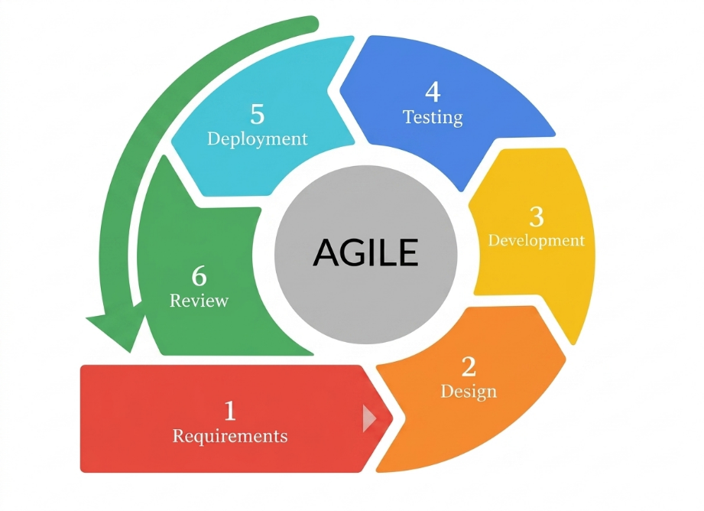
Figure 2.0 Agile Model

The Requirements phase, where the proponents will gather information through interviews and consultations with potential users, including patients, family members, and caregivers in selected households in Poblacion Candaba, Pampanga. The researchers will also review related literature and identify system needs such as medication scheduling, notification features, and monitoring requirements, which will serve as the basis for the system specifications.
The Design phase, where the proponents will create a comprehensive system plan that includes both the mobile application and the physical device. This will involve developing system architecture diagrams, flowcharts, use case diagrams, and wireframes for the application interface, as well as drafting circuit diagrams for the ESP32, sensors, servo motors, and camera module to ensure proper integration.
The Development phase, where the hardware and software components will be developed in parallel. This will include assembling the physical prototype, programming the ESP32 microcontroller using Arduino IDE, and developing the mobile application using Flutter. Firebase will be configured for real-time data synchronization and notification services, while each module will be tested individually before full system integration.
The Testing phase, where each component will undergo validation in a controlled environment to ensure proper functionality. This will include unit testing of individual parts such as the servo motors, sensors, camera, and RTC module, integration testing to verify communication between the device and the mobile application, and User Acceptance Testing (UAT) involving selected users to evaluate usability and reliability.
The Deployment phase, where the system will be implemented in a simulated home environment, followed by testing in selected households in Poblacion Candaba, Pampanga to observe real-world performance and usability.
The Review phase, where feedback from testing and user evaluation will be collected and analyzed to improve the system. Necessary adjustments and refinements will be made to both hardware and software components to enhance performance, usability, and reliability in succeeding iterations of the system.

Requirement Analysis and Documentation
The requirement analysis and documentation for the IoT-Based Smart Pill Dispenser with Real-Time Notification System will outline the functional and non-functional requirements necessary for developing a reliable and efficient prototype for home-based medication management. This documentation will serve as the foundation for identifying and defining the system’s essential features, which aim to improve medication adherence and support patients, family members, and caregivers in managing daily medication routines.
The system’s functional requirements will include the automated release of medications based on scheduled time and date settings configured through the mobile application, along with sensor-based detection to determine whether the medication has been taken within a specified time. A camera module will be integrated to provide visual monitoring of the dispensing process. The system will also send real-time notifications through a mobile application and SMS alerts to inform users of scheduled doses, missed intake, and system status. In addition, the system will allow remote control features such as disabling the device when the patient is not at home, as well as an emergency button for immediate medication access. All medication events, schedules, and system activities will be stored in a cloud-based database for monitoring and review.
For user interaction, the system will include a mobile application with role-based access, allowing patients and family members or caregivers to use a single application with different interfaces and permissions. The application will provide features such as schedule setting, real-time monitoring, notification alerts, and medication history tracking. A display module will also be included in the device to show basic system information and assist users during operation.
Regarding non-functional requirements, the system will prioritize data security through secure authentication and protected data transmission. It will be designed to be scalable, allowing additional users and medication compartments if needed. Reliability and accuracy will be emphasized to ensure consistent system performance under typical household conditions. The system will also consider usability by ensuring that both the device and mobile application are easy to understand and operate, especially for elderly users or those with limited technical experience. Finally, the system will be designed to function effectively under varying internet conditions, with SMS alerts serving as an alternative notification method when connectivity is limited.

Software Requirement Specification
This section specifies that the development of the IoT-Based Smart Pill Dispenser will rely on a combination of software tools and programming environments to ensure reliable functionality and seamless integration between hardware and software components. The table below presents the complete software specifications to be used during the development of the system.
Software / Tool | Purpose / Specification
Arduino IDE | Integrated Development Environment for programming the ESP32 microcontroller firmware
Visual Studio Code | Development environment for application coding and system integration
Flutter (Dart) | Framework for developing the Android mobile application
Firebase (Firestore) | Cloud database for storing schedules, logs, and system data
Firebase Cloud Messaging | Service for sending real-time notifications to the mobile application
Android | Target operating system for the mobile application
C++ (ESP32) | Programming language for microcontroller logic and control
Dart | Programming language used for mobile application development
Windows 10 / 11 | Development operating system
Table 1. Software Specification
Hardware Requirement Specification
This section outlines the hardware components that will be used in the development of the IoT-Based Smart Pill Dispenser. The selection of components will focus on reliability, accuracy, and suitability for home-based implementation. The table below presents the complete hardware specifications.

Component | Specification / Purpose
ESP32 Microcontroller | Main controller responsible for system operations and connectivity
DS3231 RTC Module | Maintains accurate time for scheduled medication dispensing
Servo Motors | Controls the movement of medication compartments
IR Sensor | Detects whether medication has been taken
Camera Module | Provides visual monitoring of medication dispensing
SIM800L GSM Module | Sends SMS alerts for notifications
16x2 LCD Display | Displays system status and schedule information
Power Supply | Provides stable power for the system components
Firebase Cloud Database | Stores system data, logs, and schedules
Table 2. Hardware Specification

Description of Materials
This section describes the hardware components and materials that will be used in the development of the IoT-Based Smart Pill Dispenser with Real-Time Notification System. The selection of these materials will prioritize reliability, accuracy, and seamless integration to ensure effective medication management, real-time monitoring, and user accessibility within a home-based environment.

ESP32 Microcontroller
The ESP32 will serve as the main control unit of the system. It will manage all system operations, including processing inputs from sensors, controlling the movement of the servo motors, handling communication with the cloud database, and transmitting data to the mobile application. Its built-in Wi-Fi capability will enable real-time connectivity, allowing the system to send notifications and synchronize data efficiently.

DS3231 RTC Module
The Real-Time Clock module will ensure accurate timekeeping for the system. It will maintain the correct date and time even during power interruptions, allowing the device to follow medication schedules consistently. This will be essential in ensuring that medications are accessed at the correct time without delay or error.

Servo Motors
The servo motors will be responsible for controlling the movement of the pill compartments. Each motor will rotate to position the correct medication slot during scheduled dispensing. Their precise angle control will ensure that only the intended compartment is accessed, contributing to the accuracy and reliability of the system.

IR Sensor
The infrared sensor will function as the primary detection mechanism for medication intake. It will monitor whether the pill has been removed from the dispensing area after activation. If no removal is detected within a set time, the system will recognize it as a missed intake and trigger the appropriate alert notifications.

Camera Module
The camera module will provide an additional layer of monitoring by capturing visual confirmation of the dispensing process. It will allow family members or caregivers to remotely observe whether the patient has interacted with the device, adding a level of assurance beyond sensor detection alone. This feature will support better supervision and accountability.

SIM800L GSM Module
The GSM module will enable the system to send SMS notifications to users. This will serve as a backup communication method in situations where internet connectivity is unavailable or unstable. It will ensure that important alerts, such as missed medication or system warnings, are still delivered to family members and caregivers.

16x2 LCD Display with I2C
The LCD display will provide a simple on-device interface that shows essential system information such as current time, upcoming medication schedules, and system status. The I2C interface will reduce wiring complexity and allow efficient communication with the ESP32 while conserving input/output pins.

Power Supply
The power supply will provide stable and continuous electrical support to all system components. It will ensure that the device operates reliably during daily use, maintaining consistent performance of the microcontroller, sensors, and communication modules.

Firebase Cloud Database
Firebase will serve as the cloud-based storage system for the project. It will securely store medication schedules, system logs, and user data, allowing real-time synchronization between the device and the mobile application. This will enable users to monitor activity and receive updates regardless of their location.

Mobile Application (Flutter-Based)
The mobile application will serve as the main user interface of the system. It will allow patients, family members, and caregivers to set medication schedules, receive real-time notifications, monitor medication activity, and manage system settings. The application will be designed with role-based access to provide different interfaces depending on the user type, ensuring both usability and functionality.

Design of the System
This section will present the technical blueprint used to transform the project’s requirements into a functional system, beginning with the Use Case Diagram to define how users will interact with the system. It will then outline the system logic and data movement through the Data Flow Diagram (DFD) and System Flow Chart, which will guide the structure of the database presented in the Entity Relationship Diagram (ERD). The overall integration of components will be shown through the System Architecture, followed by hardware implementation starting from the Block Diagram and finalized through the detailed Schematic Diagram that illustrates the complete wiring layout.

Use Case Diagram
The Use Case Diagram will serve as the visual representation of the functional requirements, illustrating the interactions between the primary actors and the IoT-Based Smart Pill Dispenser with Real-Time Notification System. It will define the scope of the system by identifying how each user role interacts with the system’s features and how the system responds to various inputs and conditions prior to development.
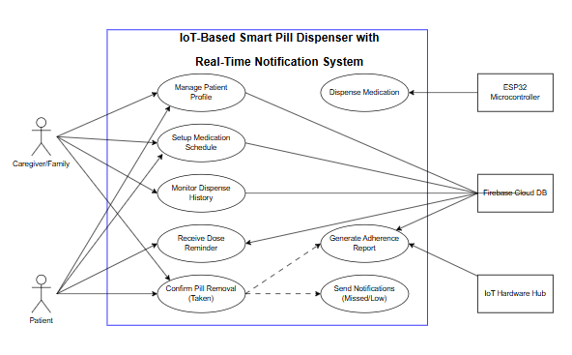
Figure 3.0 Use Case Diagram of IoT-Based Smart Pill Dispenser
Figure 3.0 illustrates the Use Case Diagram of the IoT-Based Smart Pill Dispenser, defining the functional architecture and interactions between the users and the system. The system will consist of two primary human actors: the Patient and the Caregiver/Family member, alongside integrated system components. The Patient will interact with the system by receiving dose reminders, confirming pill removal (taken), and indirectly triggering adherence tracking through their actions. The Caregiver/Family member will manage patient profiles, set up medication schedules, and monitor dispense history to ensure proper adherence.
The System, supported by the ESP32 microcontroller, Firebase Cloud Database, and IoT Hardware Hub, will handle core operations such as dispensing medication, generating adherence reports, and sending notifications for missed or low doses. It will also store and synchronize data in real time, ensuring that both Patient and Caregiver/Family members receive timely updates and alerts. Through these interactions, the system ensures accurate medication dispensing, continuous monitoring, and effective communication between users and the device for improved healthcare management.

Data Flow Diagram
The Level 0 Data Flow Diagram, also known as the Context Diagram, shown in Figure 4.0 provides a high-level overview of the Smart Pill Dispenser system as a single process and its interactions with external entities. The external entities identified are the Patient, the Caregiver/Family, the Firebase cloud platform, the Flutter Mobile Application, and the GSM module. The diagram illustrates the primary data flows into and out of the system without detailing the internal processes.
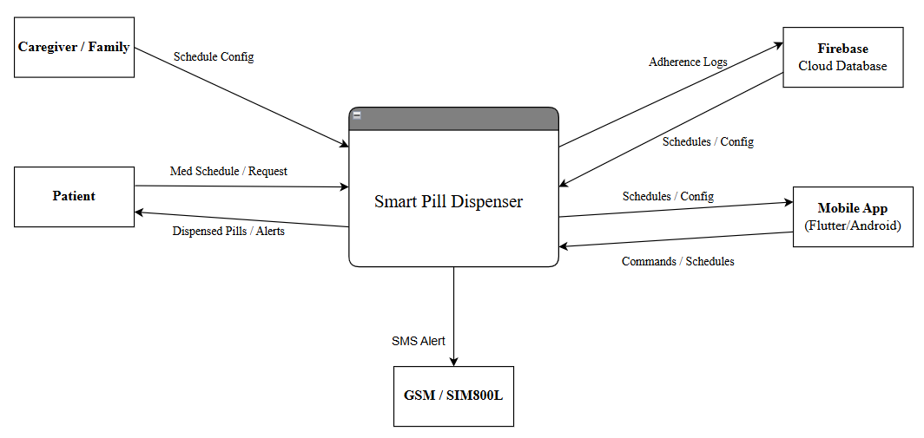
Figure 4.0 Level 0 Data Flow Diagram

The Patient provides medication schedule inputs and receives dispensed medication and real-time alerts from the system. The Caregiver/Family sends configuration and schedule data through the mobile application and receives adherence status updates and missed-dose notifications. Firebase serves as the data store and synchronization point for all schedule data and adherence logs. The Mobile Application serves as the primary user interface through which commands are sent and monitoring data is received. The GSM module serves as the output point for SMS-based backup notifications.

The Level 1 Data Flow Diagram in Figure 4.1 expands the central system process from the Context Diagram into five distinct sub-processes: Schedule Management, Dispensing Control, Sensor Verification, Notification System, and Adherence Logging. These processes detail how data will flow internally between system functions and external entities, and how the data store Medication Logs will be populated and accessed.
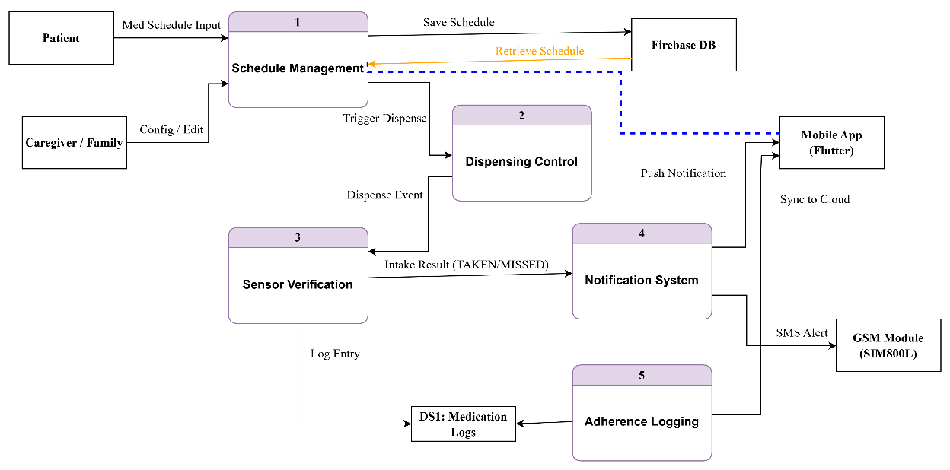
Figure 4.1 Level 1 Data Flow Diagram

Schedule Management will receive schedule inputs from the Patient and Caregiver, store and retrieve them from Firebase, and pass dispense triggers to Dispensing Control. Dispensing Control will activate the servo motor mechanism and communicate the dispensing event to Sensor Verification, which will read the IR sensor to determine whether pills were taken. The result—TAKEN or MISSED—will be passed to both Notification System, which will send push and SMS alerts, and Adherence Logging, which will write timestamped records to Medication Logs and sync with Firebase.

System Flowchart
In this section, the proponents will present the System Flowchart, which will serve as the architectural skeleton of the Smart Pill Dispenser system. By bridging the gap between abstract code and functional logic, this diagram will trace the precise lifecycle of data from input to output. It will provide a definitive map of control flow, ensuring that every loop, decision branch, and data store will be accounted for and optimized.
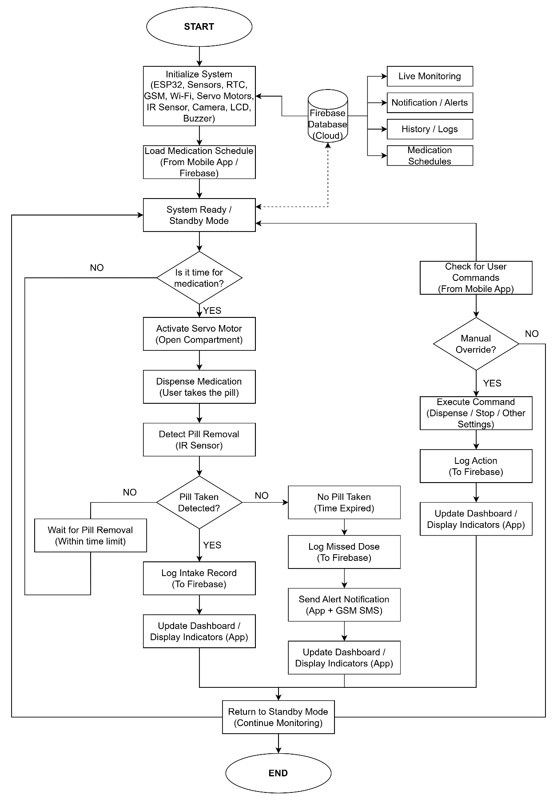
Figure 5.0 IoT-Based Smart Pill Dispenser Hardware Flowchart

Figure 5.0 will illustrate the overall operational workflow of the Smart Pill Dispenser system, detailing the interaction between the hardware components, the central processing unit, the cloud database, and the mobile application interface.
The process will begin with system initialization, where the ESP32 microcontroller, sensors, RTC module, GSM module, Wi-Fi connectivity, servo motors, IR sensor, camera, LCD, and buzzer will be configured. After initialization, the system will load the prescribed medication schedule from the mobile application or Firebase database. Once the schedule has been retrieved, the system will enter a standby or ready state, continuously monitoring the time and awaiting scheduled operations.
A real-time clock (RTC) module will be used to determine whether it is time to dispense medication. When the system time matches the scheduled medication time, the system will activate the servo motor to open the designated compartment. The medication will then be dispensed, allowing the user to take the pill. An IR sensor will be utilized to detect whether the pill has been removed within a specified time limit.
If pill intake will be successfully detected, the system will log the intake record to the Firebase database and update the mobile application dashboard to reflect successful medication adherence. Conversely, if no pill removal will be detected within the allotted time, the system will classify the event as a missed dose. It will then log the missed dose in the database and send alert notifications to the user through the mobile application and GSM SMS module. The dashboard will also be updated accordingly to reflect the missed medication event.
In parallel, the system will support remote interaction through the mobile application. It will continuously check for user commands, such as manual dispensing, stopping operations, or adjusting system settings. If a manual override will be requested, the system will execute the corresponding command, log the action to the Firebase database, and update the application dashboard in real time.
Additionally, the Firebase database will function as the central cloud repository, enabling features such as live monitoring, notification management, history logs, and medication schedule management. This integration will ensure seamless synchronization between the hardware system and the mobile application.
The operational cycle will conclude by returning the system to standby mode, where it will continue monitoring for the next scheduled medication event or user command. This continuous loop will ensure that the system remains responsive, reliable, and capable of maintaining accurate medication dispensing and monitoring at all times.

ESP32 Flowchart
This section outlined the operational logic established for the ESP32-based Smart Pill Dispenser system. As the flowchart illustrated, the process began by initializing the necessary communication modules, sensors, and dispensing components. It then moved into a continuous monitoring cycle that managed medication schedules, dispensing operations, dosage verification, and real-time notification services.
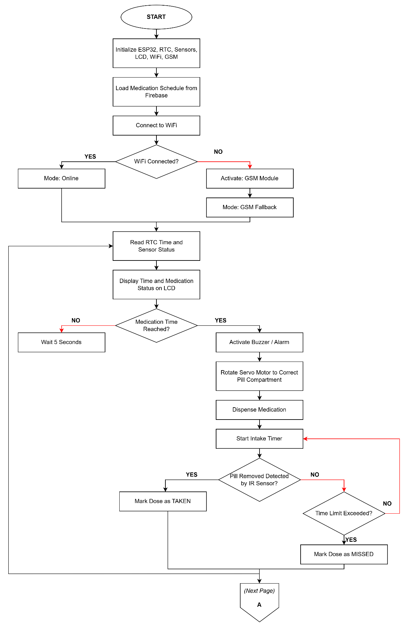
Figure 5.1 ESP32 Flowchart (Smart Pill Dispenser Control Unit)
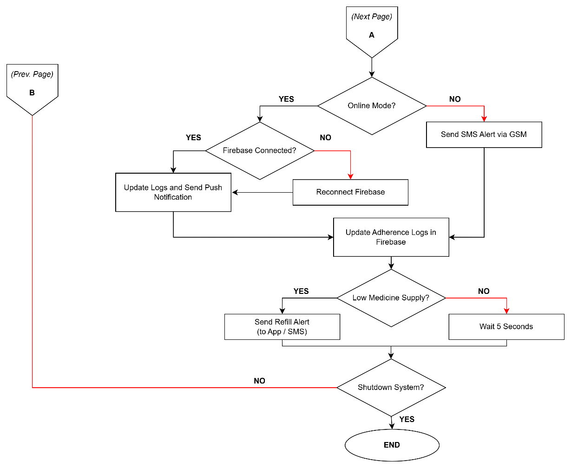
Figure 5.1 (Continued) ESP32 Flowchart (Smart Pill Dispenser Control Unit)
The functionality of the ESP32 Control Unit, illustrated in Figure 5.1 and Figure 5.1 (Continued), demonstrated a fault-tolerant control algorithm designed to maintain medication dispensing operations even during network instability. The process began with the initialization of the ESP32 microcontroller, RTC module, IR sensor, LCD display, Wi-Fi interface, and GSM communication module. Upon booting, the system immediately loaded the medication schedules stored in Firebase and attempted to connect to the local Wi-Fi network.

A decision logic evaluated the connection state: if the Wi-Fi connection succeeded, the system entered Online Mode; if the connection failed, it activated the SIM800L GSM module and shifted into GSM Fallback Mode to maintain notification capabilities through the cellular network. In either operating mode, the system entered a continuous monitoring loop where the RTC module provided real-time schedule tracking while the ESP32 continuously monitored sensor status and dispensing conditions. Current time information and medication schedule status were simultaneously displayed on the LCD interface for local monitoring.
The workflow then diverged based on the programmed medication schedule. If no medication event was scheduled, the system entered a short standby delay before restarting the monitoring cycle. Once the scheduled medication time was reached, the ESP32 activated the buzzer alarm to alert the patient and rotated the servo motor to align the correct pill compartment with the dispensing slot. The dispensing mechanism then released the medication while the intake timer simultaneously began counting the allowable confirmation period.
The system then performed dosage verification using the IR sensor detection mechanism. If pill removal was successfully detected, the system recorded the medication event as TAKEN and updated the adherence logs accordingly. However, if the IR sensor failed to detect pill removal within the configured time limit, the system classified the dose as MISSED. At this stage, the workflow evaluated the active operating mode. If the system remained in Online Mode, it verified the Firebase connection and transmitted updated adherence logs together with push notifications to the mobile application. If the Firebase connection was unavailable, the ESP32 attempted automatic cloud reconnection before retrying the synchronization process.
In GSM Fallback Mode, the system shifted to an offline notification strategy. Once a missed-dose event was detected, the SIM800L GSM module transmitted an SMS alert directly to the registered caregiver or family member to ensure that medication adherence notifications remained functional even without internet connectivity. The workflow also monitored medication inventory levels within the dispenser. If the remaining medication supply dropped below the configured threshold, the system generated refill alerts through either Firebase notifications or SMS messaging. The operational cycle concluded with a short stabilization delay and a shutdown verification stage before returning to the continuous medication monitoring loop.

Servo Motor Flowchart (The Actuator)
Figure 5.2 illustrated the workflow of the Servo Motor Actuator subsystem, which will be designed to automate the dispensing of medication compartments in the IoT-Based Smart Pill Dispenser system. The subsystem will ensure accurate positioning of the pill container and will control the dispensing process without interrupting the continuous operation of the ESP32 controller.
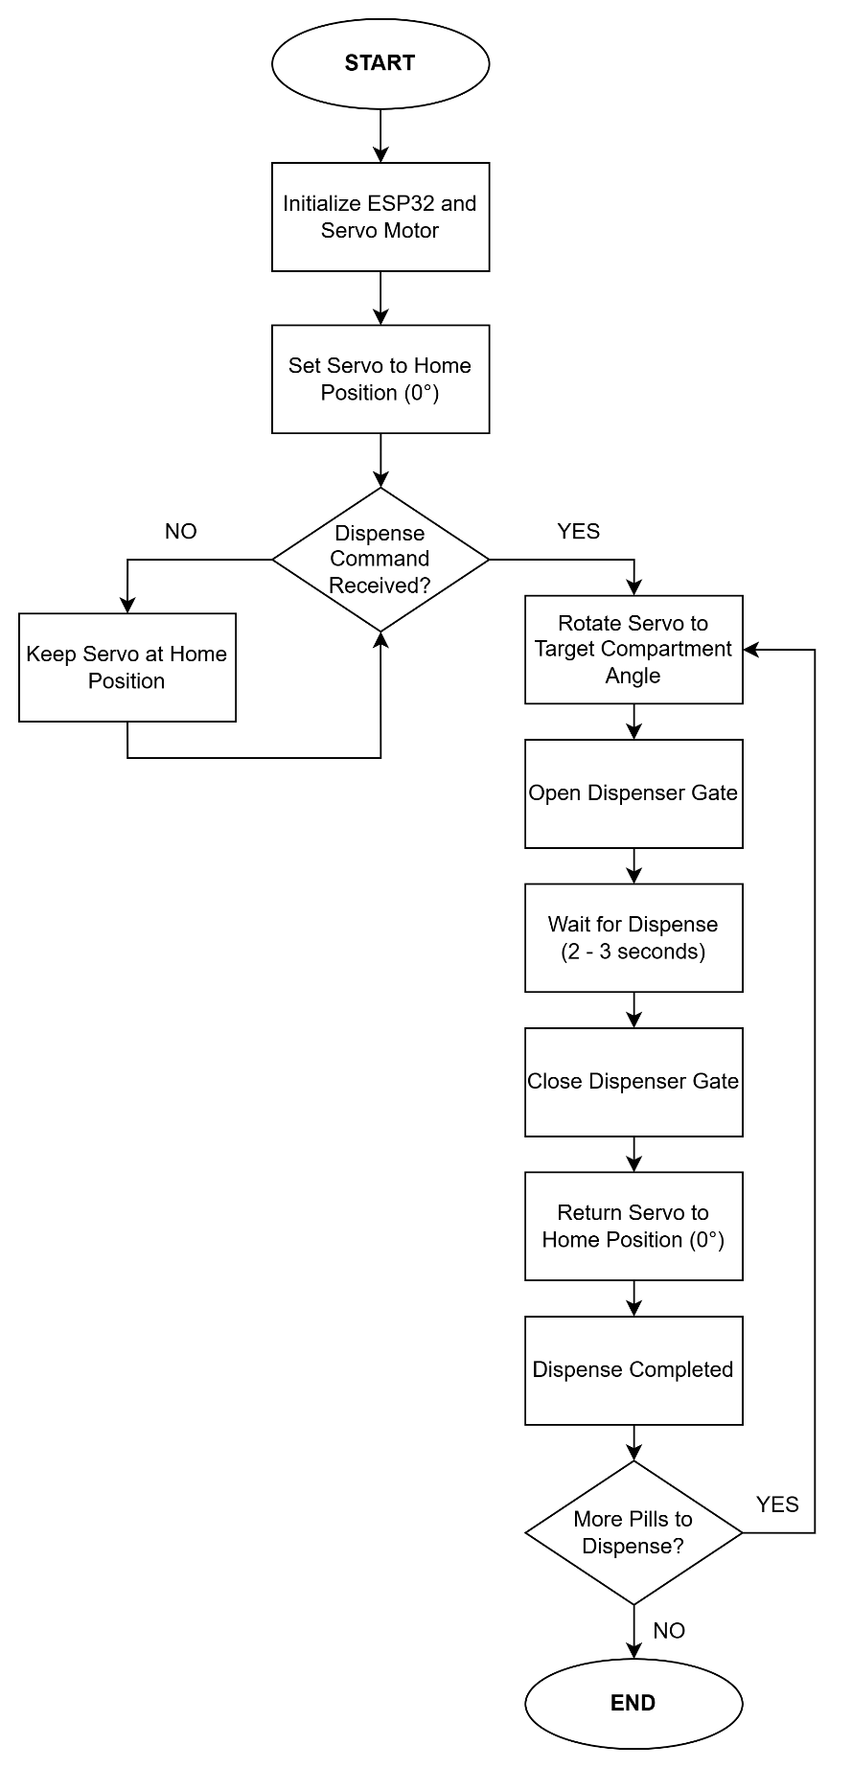
Figure 5.2 Servo Motor (Actuator) Flowchart
Figure 5.2 illustrated the operational workflow of the servo motor actuator subsystem, which will function as the primary dispensing mechanism of the Smart Pill Dispenser. The process will begin by initializing the ESP32 microcontroller and configuring the servo motor to its default home position at 0 degrees. Once initialization is completed, the system will continuously monitor for dispensing commands generated from the medication schedule stored in the database and synchronized through the ESP32 controller.
When a dispense command is detected, the system will read the assigned medication compartment and calculate the corresponding servo motor angle required for dispensing. The servo motor will then rotate to the target position to align the correct medication compartment with the dispensing slot. After reaching the target angle, the dispenser gate will be activated to release the medication into the dispensing tray. The actuator will remain active for a short dispensing duration to ensure that the medicine is properly released.
After the dispensing process is completed, the system will automatically close the dispenser gate and return the servo motor to its original home position. The system will then update the dispensing status as “Dispense Completed” and check whether additional medication schedules are queued for operation. If another dispensing request exists, the cycle will repeat for the next medication compartment. Otherwise, the actuator subsystem will remain in standby mode while waiting for the next scheduled command from the ESP32 controller.
This automated actuator design will ensure accurate medication dispensing, minimize mechanical errors, and maintain continuous readiness for future dispensing operations. The implementation of the servo motor mechanism will also support reliable medication scheduling and improve the overall efficiency of the Smart Pill Dispenser system.

Entity Relationship Diagram
The Entity Relationship Diagram (ERD) in Figure 6.0 showed the database architecture of the IoT-Based Smart Pill Dispenser with Real-Time Notification System. The researchers designed the schema as a user-centered structure to organize the relationships between medication schedules, dispensing records, notification services, and dosage verification processes.
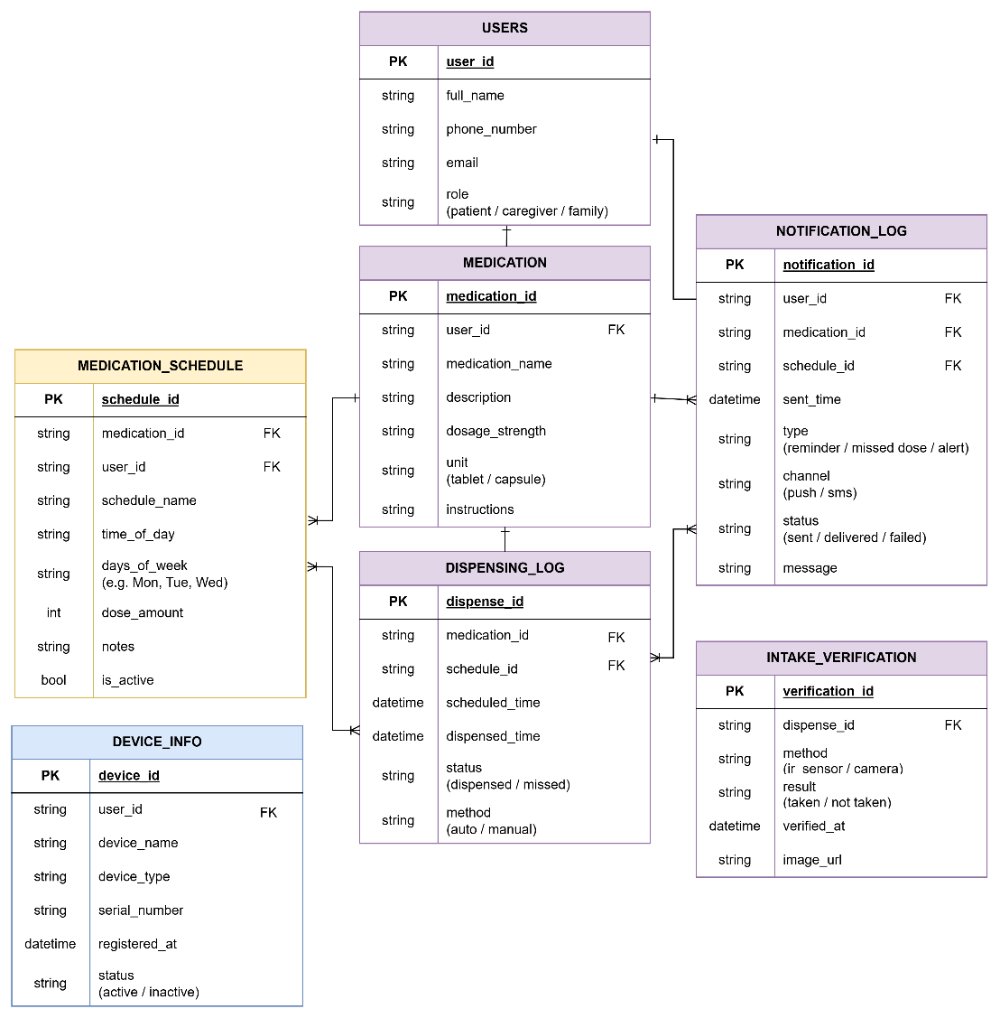
Figure 6.0 Entity Relationship Diagram
Figure 6.0 illustrated the Entity Relationship Diagram (ERD) for the Smart Pill Dispenser system, showing the logical database schema that would support the operation of the prototype. The database design followed a hierarchical structure centered on the User entity as the primary control unit. At the highest level, the User entity would manage system access by storing account credentials, contact information, and assigned roles such as Patient, Caregiver, or Family Member. A one-to-many relationship would exist between the User and Medication entities, meaning that a single user account could manage multiple medications and treatment routines simultaneously.
The system would utilize two primary scheduling and monitoring entities connected to the Medication entity to manage dispensing operations and adherence tracking. The Medication Schedule entity would store all programmed intake schedules, including dosage amounts, intake frequency, selected days, and scheduled administration times. This structure would allow the system to automate dispensing operations according to the prescribed treatment plan. Complementing this would be the Dispensing Log entity, which would record all dispensing activities performed by the device. The table would maintain timestamped records of scheduled doses, actual dispensing times, dispensing methods, and missed-dose events to support long-term adherence monitoring and historical reporting.
The system would monitor notification delivery and medication intake verification through two additional logging entities. The Notification Log entity would function as the centralized communication record for all alerts transmitted through Firebase Cloud Messaging and the SIM800L GSM module. This entity would store notification types, delivery channels, timestamps, and notification status to verify successful reminder transmission and missed-dose escalation procedures. Meanwhile, the Intake Verification entity would focus specifically on confirming medication intake using IR sensor detection and optional camera-based monitoring. This table would document the verification method used, the confirmation result, and the associated dispensing record, ensuring that adherence reports reflected actual medication removal events rather than simple dispensing actions.
To support device management and system maintenance, the Device Information entity would store details related to registered Smart Pill Dispenser units, including device identifiers, hardware status, registration timestamps, and device ownership mappings. All operational entities would maintain one-to-many relationships with the User and Medication entities, enabling the system to generate comprehensive medication adherence histories, notification records, and dispensing analytics for each individual patient profile.

System Architecture
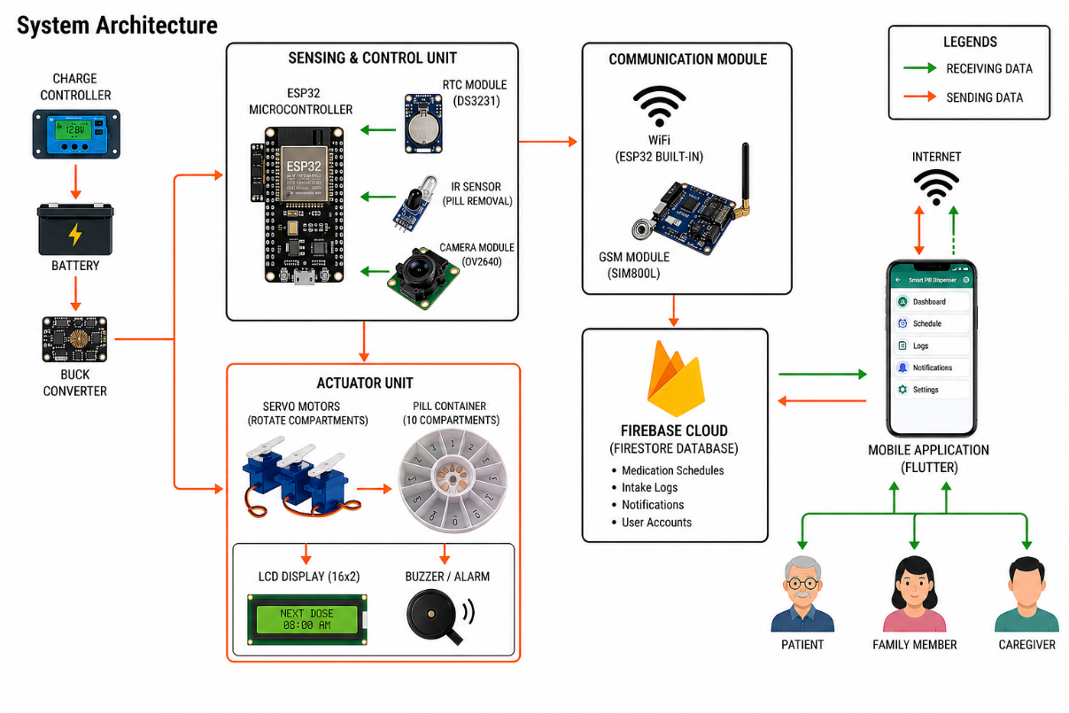
Figure 7.0 System Architecture
Figure 7.0 The System Architecture illustrated the integration of embedded hardware, IoT communication, and mobile application technologies for the IoT-Based Smart Pill Dispenser with Real-Time Notification System. It began with a power management subsystem where a charge controller maintained a rechargeable battery, with a buck converter providing stable power distribution to all components for continuous and reliable system operation.

The hardware was structured into two primary units: an ESP32 microcontroller that managed real-time medication scheduling, sensor monitoring, and wireless communication through the RTC module, IR sensor, and OV2640 camera module, and an actuator unit that handled hardware actuation using servo motors to rotate the pill compartments for automated medication dispensing. The actuator unit also incorporated a 16x2 LCD display for real-time schedule and status monitoring, alongside a buzzer or alarm module for medication reminders and alerts.

The Firebase Cloud acted as the central communication and database platform, consolidated data from the ESP32 and communication modules, and served as the cloud hub for the entire system. It utilized Firebase Firestore as a real-time database for bidirectional data flow, storing medication schedules, intake logs, notifications, and user account information. Through internet connectivity and the SIM800L GSM module, the system enabled users via a Flutter-based Mobile Application to monitor medication adherence, receive real-time notifications, review logs, and remotely manage medication schedules from selected households in Candaba, Pampanga.

Block Diagram
The design of the IoT-Based Smart Pill Dispenser with Real-Time Notification System was mapped out in the block diagram shown in Figure 8.0. This illustration separated the system into its key components, which helped explain the data flow, communication process, and control logic that will be used throughout the medication management system.
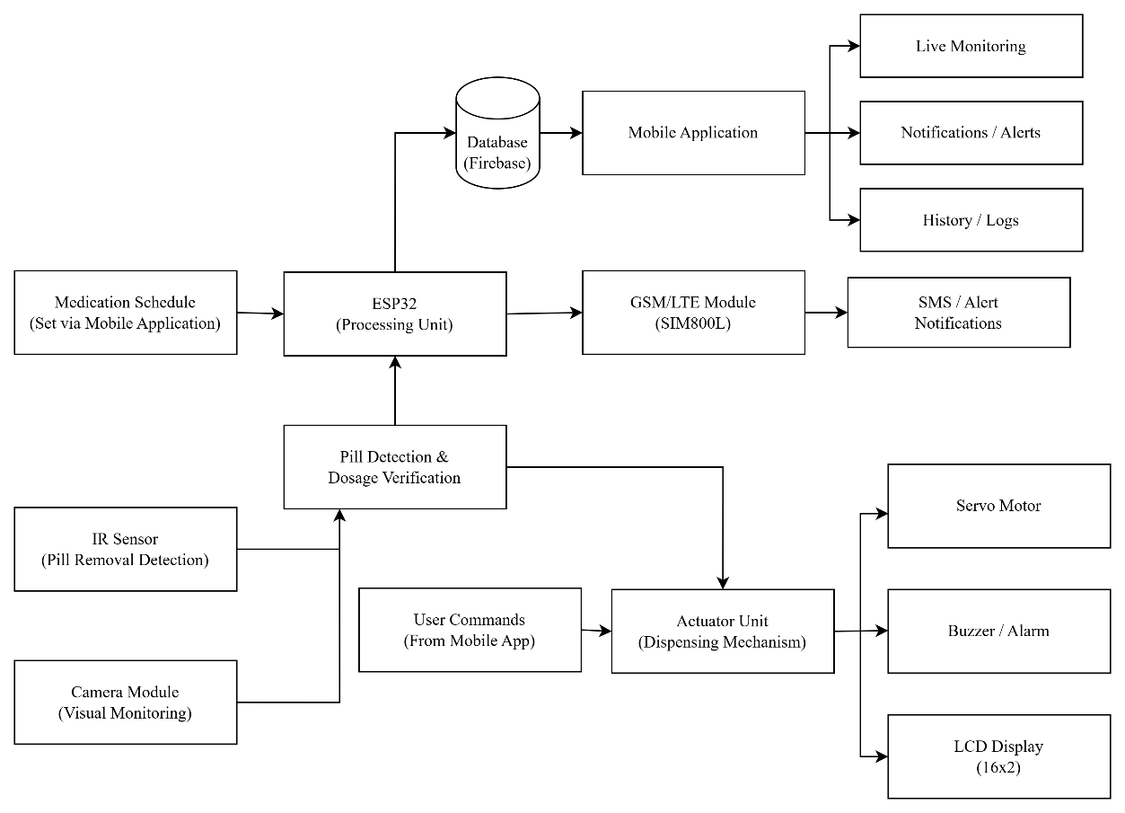
Figure 8.0 Block Diagram
The Block Diagram in Figure 8.0 will illustrate the overall design and operational flow of the Smart Pill Dispenser system, showing how the processing unit, cloud database, sensors, actuators, and mobile application will interact with one another. At the core of the system, the ESP32 microcontroller will serve as the main processing unit responsible for coordinating medication scheduling, sensor monitoring, dispensing operations, and communication with the cloud database and mobile application.
The process will begin with medication schedules configured through the mobile application, which will be stored in the Firebase database and transmitted to the ESP32. The ESP32 will then process the scheduling data and control the dispensing mechanism at the designated medication time. For communication and notification services, the system will utilize Firebase Cloud for real-time synchronization and the SIM800L GSM/LTE module for SMS-based alert notifications during low or unstable internet connectivity. Through the mobile application, users will be able to perform live monitoring, receive notifications or alerts, and review medication history and intake logs in real time.
For monitoring and verification, the system will incorporate an IR sensor for pill removal detection and a camera module for visual monitoring. These components will support pill detection and dosage verification by confirming whether the medication has been removed from the dispensing tray after release. The collected verification data will then be transmitted back to the ESP32 for processing and logging.
For physical control and user interaction, the actuator unit will function as the dispensing mechanism of the system. It will receive commands from both the ESP32 and the mobile application to operate the servo motor responsible for rotating the pill compartments. The actuator unit will also control the buzzer or alarm module for audible medication reminders and the 16x2 LCD display for showing real-time schedule and system status information. This integrated structure will enable automated medication dispensing, real-time adherence monitoring, and remote supervision through the cloud-connected mobile application.

Schematic Diagram
These schematic diagrams presented the overall layout of the hardware connections and power distribution within the setup. This visual guide demonstrated how the various components were integrated to form the complete monitoring system.
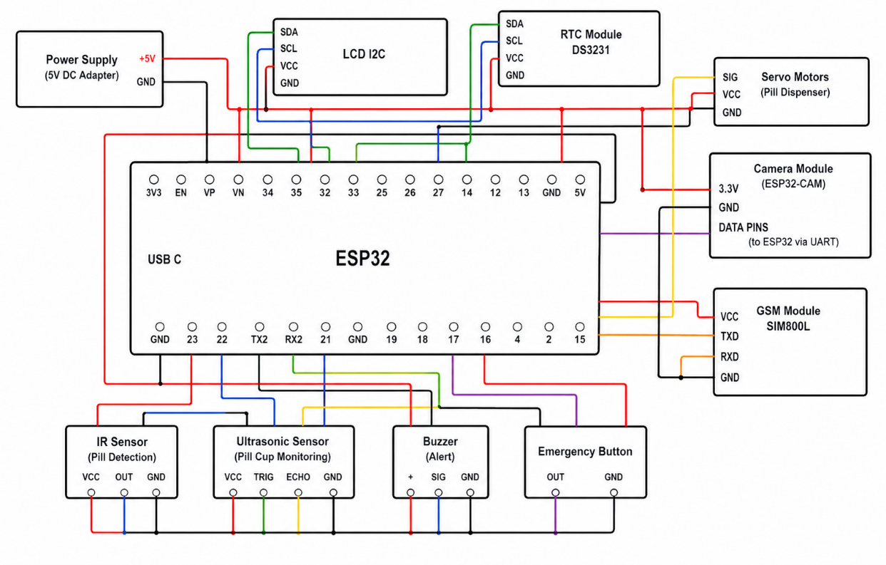
Figure 9.0 Schematic from ESP32 to Sensors
Figure 9.0 illustrated the schematic layout in which the ESP32 microcontroller operated as the central hub, powered by a regulated 5-volt supply. It connected to a suite of sensors including the IR sensor for pill detection and the ultrasonic sensor for pill cup monitoring. The diagram detailed the specific wiring for each device, distinguishing the digital connections sent to the ESP32’s GPIO pins for signal transmission. Additionally, the buzzer served as an alert mechanism, while the emergency button functioned as a manual input control. The included connections represented how the ESP32 interpreted incoming signals and triggered corresponding outputs, enabling real-time monitoring and reliable operation of the Smart Pill Dispenser system.
Figure 9.1 illustrated the power distribution network designed to support the reliable and continuous operation of the Smart Pill Dispenser system. The design focused on ensuring stable power delivery to all electronic components involved in sensing, processing, communication, and actuation within the system.
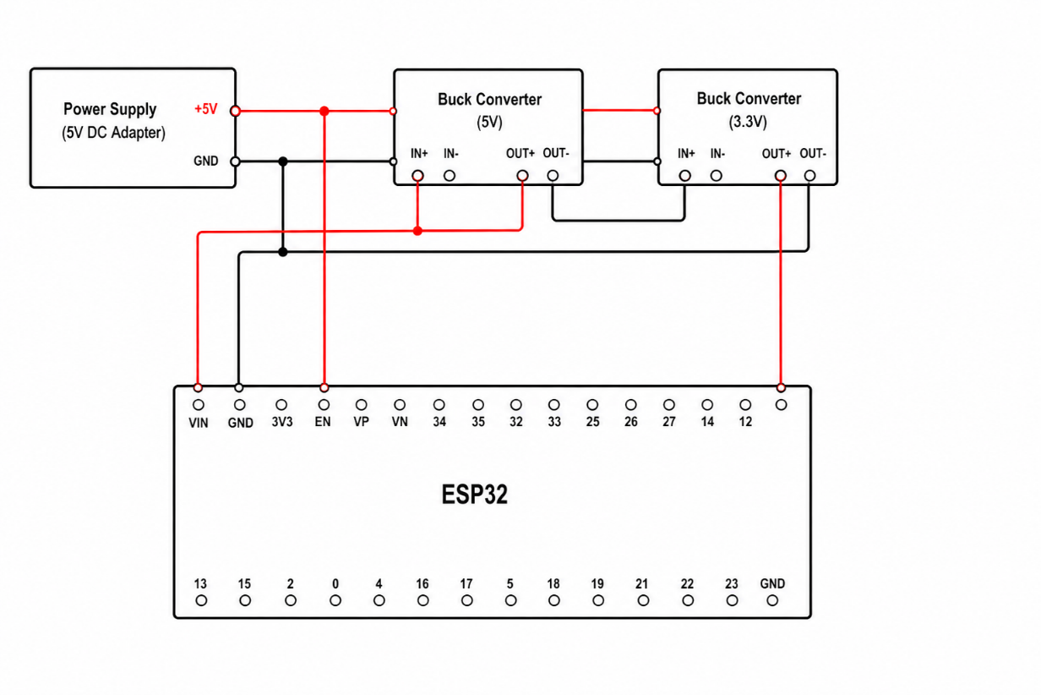
Figure 9.1 Schematic from Power Supply to ESP32
The power delivery process began with a 5V DC power supply adapter, which served as the primary energy source of the system. This input was regulated and routed into a stable 5V supply line, which then powered the ESP32 microcontroller as the central control unit responsible for coordinating all system operations and decision-making processes.
From the main supply line, power was distributed through a shared 5V and GND rail to ensure consistent voltage levels across all connected modules. The ESP32 managed system functionality while also interfacing with peripheral devices such as the servo motors, IR sensor, ultrasonic sensor, GSM module, LCD I2C display, and RTC module. For components requiring lower voltage, a 3.3V line was provided to support devices such as the ESP32-CAM, ensuring proper voltage compatibility and safe operation.
Communication and control were maintained through multiple interfaces integrated into the system architecture. The LCD I2C display and RTC module were connected via I2C lines (SDA and SCL) for real-time monitoring and time-based functions, while the GSM module and ESP32-CAM utilized UART communication for data transmission. Overall, this integrated power distribution design ensured that all system components operated efficiently and harmoniously within a single, stable electrical network.

Figure 9.2 illustrated the electrical schematic for the system's dispensing and monitoring subsystem, establishing the ESP32 as the core controller. The circuit utilized a regulated power distribution network where the ESP32 supplied control signals and power to peripheral components including the servo motor, sensors, communication modules, and alert devices, ensuring coordinated operation within the automated pill dispensing system.
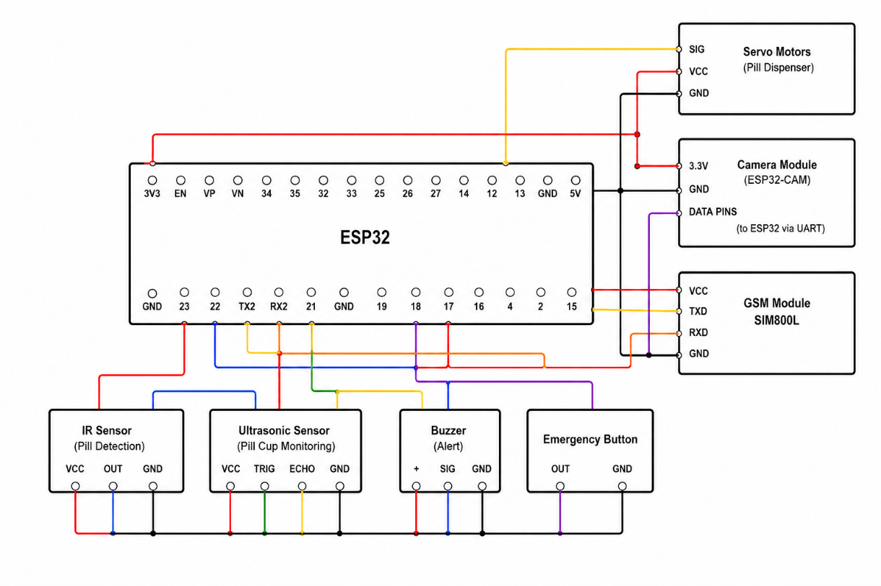
Figure 9.2 Schematic from Servo Motors to Sensors
The diagram detailed an integrated control system where a Servo Motor regulated the pill dispensing mechanism through a PWM-enabled GPIO pin of the ESP32. A Camera Module (ESP32-CAM) was incorporated to provide visual monitoring of the dispensing process, while the SIM800L GSM module enabled wireless communication through UART connections, allowing the system to transmit notifications or alerts to caregivers. For pill monitoring, an IR Sensor detected the presence of dispensed medication, while an Ultrasonic Sensor measured the distance within the pill cup to monitor dispensing status. A Buzzer was included to provide audible alerts during scheduled medication times, and an Emergency Button allowed the user to manually trigger an alert in case of urgent situations. This design ensured reliable coordination between actuation, sensing, and communication components while maintaining stable electrical connections through a shared grounding network.

Statistical Treatment
To ensure a rigorous and systematic interpretation of the data gathered in this study, descriptive statistical tools will be utilized in accordance with a quantitative research design. These methods will be applied to evaluate both the system performance and user feedback of the Smart Pill Dispenser.

A. Data Analysis Tools
The quantitative data to be gathered from system evaluation results and user assessments will be analyzed using descriptive statistics to determine system efficiency, reliability, and user satisfaction.

1. Weighted Mean
The Weighted Mean will be used to measure the central tendency of the respondents’ evaluations in terms of usability, functionality, reliability, and overall system performance. This will be applied to the Likert-scale responses gathered from both technical experts during Alpha testing and end-users during Beta testing.

The study will utilize a four-point Likert scale, where each response is assigned a corresponding weight: Strongly Agree (4), Agree (3), Disagree (2), and Strongly Disagree (1). These values will be multiplied by their respective frequencies and divided by the total number of respondents to obtain the Weighted Mean.

𝛴𝑓𝑥
Formula: 𝑥 =
𝑓

Where:
𝑥 = weighted mean
𝛴𝑓𝑥 = sum of the product of frequency and weight
𝑓 = total number of respondents

A higher weighted mean will indicate a higher level of satisfaction, agreement, or system acceptability.

2. Likert Scale Interpretation
To properly interpret the computed results, the study will use a four-point Likert scale with corresponding verbal interpretations. The weighted mean results will be classified using the following range and descriptive equivalents:

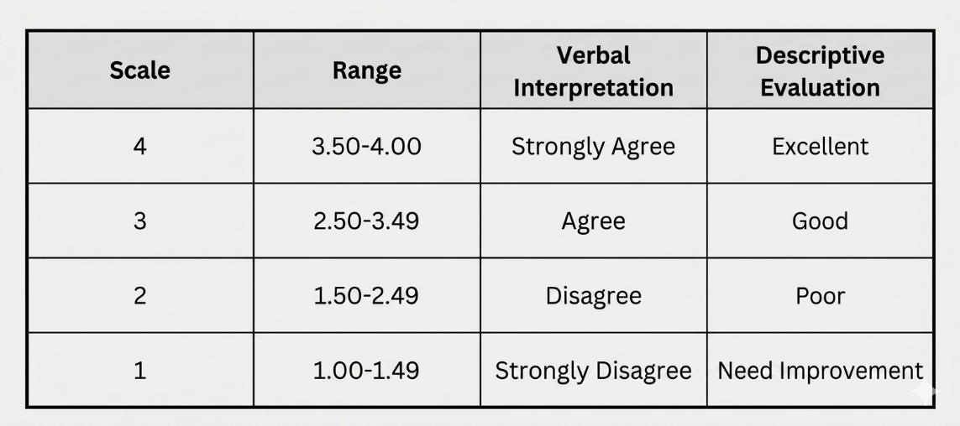
Table 3.0 Four Point Likert Scale

3. Descriptive Statistics for System Data
Sensor-generated data from the Smart Pill Dispenser, including pill removal detection events and system response logs, will be analyzed using descriptive statistical measures. The Mean will be used to determine the average system response and performance consistency, while Frequency will be used to record dispensing success rates and alert occurrences. These values will provide an overview of system reliability and operational efficiency during testing and deployment.

The computed results from both user evaluation and system-generated data will be used to assess the overall performance of the Smart Pill Dispenser in terms of functionality, reliability, and usability.

Sampling Technique
To ensure the integrity and relevance of the gathered data, the proponents will employ purposive sampling for both the alpha and beta testing phases of the IoT-Based Smart Pill Dispenser with Real-Time Notification System. This non-probability sampling method will allow the researchers to specifically select participants who possess the necessary knowledge, experience, and characteristics to effectively evaluate the system. The approach is appropriate for the study since it targets a specific group, particularly households in Candaba, Pampanga with members who require regular medication management.
During the initial phase, a group of external technical evaluators will be purposively selected to assess the system’s technical and architectural components. This group will consist of Information Technology professionals and individuals with backgrounds in embedded systems, IoT, or mobile application development. They will evaluate the system in terms of functionality, integration, and overall performance based on the ISO/IEC 25010 Software Quality Model and ISO/IEC 30141 IoT Reference Architecture. Their feedback will be used to identify issues and refine the system prior to user deployment.
For the field-testing phase, the proponents will focus on selected households in Candaba, Pampanga. Participants will include patients who are required to take regular medication, along with their family members or caregivers who assist in medication management. These respondents will be selected based on their direct involvement in daily medication routines, allowing them to assess the system’s usability, reliability, and practicality in a real-world home environment.
In summary, the capstone project will involve both technical evaluators and end users to ensure a balanced assessment of the system. This approach will provide a combination of technical validation and practical user feedback, ensuring that the system is evaluated comprehensively in terms of both performance and real-world applicability.

Respondents
The respondents of this capstone project will consist of two distinct groups, categorized according to the specific requirements of the system evaluation phases. To ensure that participants possess the necessary technical competence and practical experience, the researchers will employ purposive sampling in selecting the respondents. The first group will consist of technical experts for the alpha testing phase, while the second group will include selected patients together with their family members or caregivers from households in Candaba, Pampanga for the beta testing phase.
For the alpha testing phase, the researchers will engage a group of technical experts with professional backgrounds in Information Technology, embedded systems, or mobile application development. Their primary role will be to conduct a thorough technical evaluation of the system prior to deployment. To ensure a comprehensive assessment, these experts will utilize recognized standards such as ISO/IEC 30141 for evaluating the system’s IoT architecture and ISO/IEC 25010 for assessing software quality in terms of functionality, reliability, usability, and performance. The feedback gathered from these experts will be used to refine the system before it is introduced to actual users.
In the beta testing phase, the researchers will focus on selected households in Candaba, Pampanga, particularly those with patients who are required to take regular medication. The respondents will include patients as well as their family members or caregivers who are directly involved in medication management. These participants will interact with the system in a real-world home environment and will evaluate its usability, functionality, reliability, and overall acceptability. The sample size for this phase will be determined using an appropriate statistical method, such as Slovin’s Formula, once the total population of qualified respondents has been finalized.

Research Tools and Instrument
The primary research instrument to be utilized in this study will be a structured survey questionnaire, carefully designed based on international standards to ensure a comprehensive evaluation of the IoT-Based Smart Pill Dispenser with Real-Time Notification System. To address the integrated nature of the project, which includes both hardware components and a mobile application, the researchers will incorporate evaluation criteria from ISO/IEC 30141, known as the Internet of Things Reference Architecture, and ISO/IEC 25010, referred to as the Systems and Software Quality Requirements. This combined approach will allow a holistic assessment of the system’s technical performance and overall user experience.
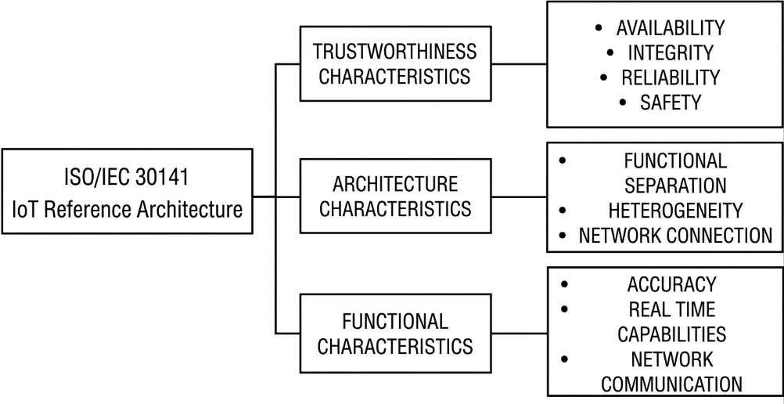
Figure 10.0 ISO/IEC 30141 Model
For the evaluation of the hardware and system architecture, the instrument will adopt the core characteristics of ISO/IEC 30141. This section of the questionnaire will focus on assessing the system’s connectivity, data flow, device integration, and overall reliability. It will measure how effectively the system performs in terms of real-time communication between the device, cloud database, and mobile application, as well as its ability to maintain consistent operation in a home-based environment.
At the same time, the mobile application and system software will be evaluated using the quality characteristics defined in ISO/IEC 25010. This portion of the instrument will assess functional suitability, performance efficiency, usability, reliability, and security. It will determine how effectively the system delivers notifications, supports user interaction, and provides an accessible interface for patients, family members, and caregivers.
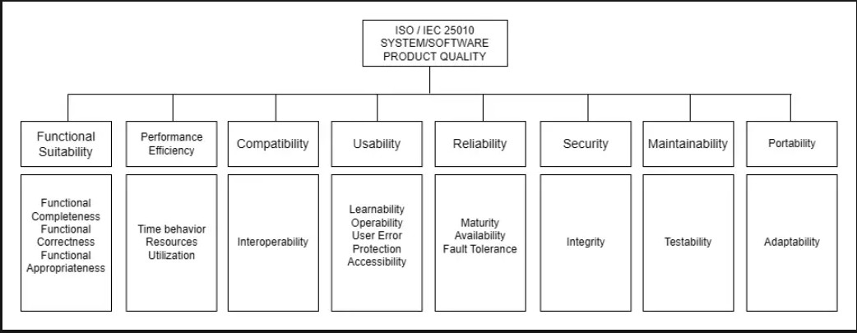
Figure 11.0 ISO/IEC 25010 Model
In addition to the survey questionnaire, the researchers will utilize supplementary tools to strengthen the validity of the collected data. These will include system performance logs that record objective metrics such as dispensing accuracy, sensor detection results, notification delivery time, and system response behavior. These data will be analyzed alongside the survey responses to provide a more comprehensive evaluation of the system’s effectiveness, reliability, and user acceptability.

Development and Testing
The development of the IoT-Based Smart Pill Dispenser with Real-Time Notification System will follow the Agile methodology, ensuring an iterative, flexible, and collaborative process. This approach will allow the researchers to accommodate user feedback and evolving requirements throughout the system’s development. By implementing continuous improvement and incremental development, the system’s hardware and software components will be refined progressively to ensure functionality, reliability, and usability.
The mobile application will be developed using Flutter, a cross-platform development framework that will allow deployment through a unified codebase. This strategic choice will ensure accessibility for patients, family members, and caregivers while maintaining consistent performance and interface design. Flutter’s reactive framework will support real-time data updates, enabling users to monitor medication schedules, receive notifications, and access system information through an intuitive interface. The application will undergo testing across different Android devices to ensure consistent performance and reliability.
For the IoT components, the ESP32 microcontroller will be programmed using the Arduino IDE. The development process will begin with the testing of individual hardware components, including the servo motors, RTC module, sensors, camera module, and GSM module, to ensure proper functionality. The dispensing mechanism will be constructed using multiple servo motors controlling the medication compartments, with each unit calibrated to ensure accurate alignment. The sensors will be configured to detect whether medication has been taken, while the camera module will provide visual monitoring. The GSM module will be integrated to enable SMS notifications in cases where internet connectivity is limited.
Simultaneously, the Firebase platform will be configured to support cloud-based data storage, real-time synchronization, and notification services. The system will utilize Firestore for storing medication schedules, logs, and user data, while Firebase Cloud Messaging will be implemented to deliver real-time alerts. The ESP32 firmware will be developed incrementally, beginning with schedule control and servo operation, followed by sensor integration, cloud communication, and fallback notification mechanisms.
Prior to external evaluation, the researchers will conduct internal testing consisting of unit testing and system integration testing. During unit testing, individual hardware and software components will be tested independently to verify accuracy and functionality. This will include validating servo movement, sensor detection, scheduling logic, and notification triggers. Integration testing will then be performed to evaluate the communication between the hardware device, cloud database, and mobile application, ensuring that all components operate together as a complete system.
During the alpha testing phase, selected technical experts will evaluate the system’s functionality, hardware and software integration, and overall performance. Their feedback will be used to identify issues and improve system reliability. In the beta testing phase, actual users, including patients and their family members or caregivers, will interact with the system in a real-world home environment through User Acceptance Testing. They will assess the system’s usability, reliability, and effectiveness in supporting medication management.
Both testing phases will follow the ISO/IEC 25010 Software Quality Model and ISO/IEC 30141 Internet of Things Reference Architecture to ensure that the system meets recognized international standards. The feedback gathered from these evaluations will guide further refinements, resulting in a functional and reliable system suitable for home-based use.

Implementation Plan
The implementation of the IoT-Based Smart Pill Dispenser will be guided by the Agile methodology. This iterative and incremental approach will ensure flexibility, continuous user feedback, and progressive delivery of an intelligent medication management system designed for selected households in Candaba, Pampanga. The system development will be organized into six phases: Requirements, Design, Development, Testing, Deployment, and Review, allowing continuous refinement throughout the development lifecycle.

A. Requirements Phase
The Requirements Phase will involve the identification and analysis of system requirements through literature review and informal consultations with intended users such as patients and caregivers who manage regular medication schedules. This phase will determine the essential functionalities of the system, including automated time-based medication dispensing, real-time mobile notifications, sensor-based pill intake verification, SMS fallback alerts, and cloud-based medication logging.
During this phase, the technology stack will also be defined. The ESP32 microcontroller will be selected as the main controller due to its IoT capability and wireless communication features. Flutter will be used for mobile application development, while Firebase will be adopted for real-time database management and notification services. The SIM800L GSM module will be included to provide SMS-based alerts in situations where internet connectivity is unavailable or unstable.
B. Design Phase
In the Design Phase, the gathered requirements will be translated into technical specifications and system architecture. This will include the development of system architecture diagrams, hardware schematics, and software flowcharts to define how each component will interact within the system.
Mobile application wireframes will be designed using Flutter UI principles to ensure accessibility and usability, especially for elderly users and caregivers. In addition, the Firebase database structure will be planned to include collections for medication schedules, dispensing logs, and user profiles. The mechanical design of the pill compartment system and servo-based dispensing mechanism will also be finalized during this phase to ensure precise and reliable operation.
C. Development Phase
The Development Phase will involve the parallel construction of hardware and software components following an iterative Agile approach. On the hardware side, components such as servo motors, RTC module, IR sensor, GSM module, and LCD display will be individually tested and gradually integrated with the ESP32 microcontroller. The pill dispensing mechanism will be fabricated and calibrated to ensure accurate alignment and controlled dispensing.
On the software side, ESP32 firmware will be developed incrementally, starting from time synchronization and scheduling functions, followed by servo control, sensor integration, and cloud communication with Firebase. The Flutter mobile application will also be developed simultaneously, including features such as user authentication, medication scheduling, real-time monitoring dashboard, notification system, and adherence tracking. Firebase services will be configured to enable real-time synchronization and push notifications across devices.
D. Testing Phase
The Testing Phase will be conducted in multiple levels to ensure system reliability, accuracy, and performance. Unit testing will be performed on individual hardware components such as servo motors, sensors, RTC module, and GSM communication to verify proper functionality.
Integration testing will follow to ensure that all system components, including the ESP32 firmware, Firebase database, and mobile application, will work seamlessly together. This phase will validate real-time data transmission, correct dispensing execution, and notification delivery.
Finally, User Acceptance Testing (UAT) will be conducted with selected end-users such as patients and caregivers. The system will be evaluated under simulated real-world conditions, and feedback will be collected in terms of usability, reliability, and effectiveness in supporting medication adherence.
E. Deployment Phase
After successful testing and refinement, the system will be deployed in selected households in Candaba, Pampanga for real-world implementation. The deployment will focus on evaluating system performance under actual medication schedules and household conditions.
Security measures such as Firebase Authentication and data access control will be implemented to ensure safe handling of user information. The system will be configured to operate continuously using both internet-based and GSM-based communication to ensure uninterrupted service.
F. Review Phase
The Review Phase will involve continuous evaluation and improvement of the system based on user feedback and performance results gathered during deployment. Issues identified will be documented and addressed through iterative Agile refinement cycles.
System performance will be assessed in terms of accuracy, reliability, responsiveness, and usability. Enhancements will be applied to both hardware calibration and software logic to improve overall system efficiency.
Furthermore, insights collected from real-world usage will be analyzed to identify potential future improvements such as predictive medication scheduling, intelligent adherence monitoring, and expanded IoT integration. Documentation will be continuously updated to support system scalability and future development.

REFERENCES

Jimmy, B., & Jose, J. (2011). Patient medication adherence: Measures in daily practice. Oman Medical Journal, 26(3), 155–159. https://doi.org/10.5001/omj.2011.38
Kini, V., Ho, P. M., & Granger, B. B. (2021). Medication adherence: Importance, issues and policy: A policy statement from the American Heart Association. Circulation, 143(17), e1–e18. https://doi.org/10.1161/CIR.0000000000000963
Sabaté, E. (Ed.). (2003). Adherence to long-term therapies: Evidence for action. World Health Organization
Chandana et al. (2022). IoT-Based Smart Medication Reminder and Dispensing Machine. https://ieeexplore.ieee.org/document/9743097
SS Sadi et al. (2024). IoT-Based Real-Time Medicine Reminder and Dispenser for Elderly Patients. https://ieeexplore.ieee.org/document/10691910
Peddisetti et al. (2024). Smart Medication Management Using IoT-Based Pill Dispenser and Smart Cup. https://ieeexplore.ieee.org/document/10504319
Tiwari & Raman, (2024). Smart Pill Dispenser and IoT: Advancements in Medication Administration. https://ieeexplore.ieee.org/document/10481624
Guerrero-Ulloa et al. (2020). IoT-Based Smart Medicine Dispenser to Control and Supervise Medication Intake. https://journals.sagepub.com/doi/10.3233/AISE200021
Lima et al. (2022). Development of a Pill Dispenser: System Requirements and Product Architecture. https://link.springer.com/chapter/10.1007/978-3-031-20364-0_29
Lgargioni et al. (2024). A Systematic Review on Pill and Medication Dispensers from a Human-Centered Perspective. https://link.springer.com/article/10.1007/s41666-024-00161-w A Review on Kini et al. (2021). Dispenser Mechanisms of Medicine Dispenser. https://d1wqtxts1xzle7.cloudfront.net
Razizatunnisa et al. (2025) Improving Medication Adherence in Elderly Patients Through IoMT-Enabled Smart Pill Dispensers: A Narrative Review. (2025). https://ieeexplore.ieee.org/document/11132209
Viana, et al. (2024). Developing a Smart Pill Dispenser to Support Aging Individuals. https://link.springer.com/chapter/10.1007/978-3-031-76156-0_3
Mitra et al., (2025). IoT-Based Smart Medicine Dispenser with Real-Time Alerts and Monitoring. https://ijsci.com/index.php/home/article/view/308
Avvari et al. (2023). IoT and ML-Based Smart Pill Dispenser (SPD) Application for Monitoring Elderly People. https://researcher.manipal.edu
Nagchandi et al., (2024). IoT-Based Smart Pill Reminding System. https://doi.org/10.2174/2666255816666230911151545
Mohanty et al., (2025).A Smart Pill Reminder with Configurable Alerts, Multi-Modal Notifications, and Integrated Health Monitoring for Medical Adherence. https://doi.org/10.36548/jismac.2025.2.002
Hidayat and Irianto (2025) AutoMedic: Framework of Automatic Pill Dispenser System with Human-Centered Design Method. https://ijicom.respati.ac.id
Anisha Vaish, (2024). Automated Pill Dispenser to Improve Medication Compliance, Efficiency, and Accuracy. https://ieeexplore.ieee.org/document/10607078
Aung and Maneetham (2023). Automatic Pill Dispenser for Pharmacy. https://d1wqtxts1xzle7.cloudfront.net
Vijayalakshmi et al. (2026) Smarter Medic Monitoring System with Pill Dispenser for Patients Receiving Medication. https://ieeexplore.ieee.org/document/11407660
Chavan, et al. (2023). Design and Development of Smart Pill Dispenser. https://ieeexplore.ieee.org/document/10180698
Sharanya and TR (2024). Pill Dispenser for Elderly Care Using IoT. (2024). https://ieeexplore.ieee.org/document/10837916
Maaño et al., (2025). SmartMed: An IoT-Enabled Pill Dispensing and Monitoring System for Medication Adherence of AFib Patients. https://mseuf.edu.ph
Aquino et al. (2025). MediMinder: A Smart Device for Medication Adherence. https://journals.umak.edu.ph
Optimizing Medication Adherence with Time Pill Dispenser: A Research Project. (n.d). https://www.studocu.com
St. Paul University Study, (2024). Smart Pill Dispenser for Elderly Care. https://www.scribd.com
Automatic Pill Dispenser with SMS Notification. (2023). https://www.scribd.com
Factors Associated with Medication Adherence of Hypertensive Patients in the Philippines: A Systematic Review. (2021). https://link.springer.com
Dino et al. (2025). Utilization of Artificial Intelligence in Reducing the Incidence of Medication Error: A Bibliometric Analysis. https://onlinelibrary.wiley.com
Medication Reminder System (MRS) for Hypertensive Patients. (2023). https://www.herdin.ph
Catindoy et al. (2024). Medication Reminder and Tracker Application. https://doi.org/10.1109/ICVEE63912.2024.10823699
Kataria et al. (2021). The Smart Pill Sticker: Introducing a Smart Pill Management System Based on Touch-Point Technology. https://pubmed.ncbi.nlm.nih.gov
Effects of SMS Reminders on Medication Adherence Among Hypertensive Patients: A Randomized Clinical Trial. https://spud.herdin.ph
A Comparative Study on Alarm Reminder Versus Calendar-Based System in Improving Medication Adherence. (2023). https://www.herdin.ph
Lacap et al. (2025). Smart Pill Dispenser with Medicine Detection for Senior Citizens. https://ieeexplore.ieee.org/document/11282129
O’Connor, C. E. (2024). Mobile Phone Adherence Support for HIV Patients in Manila, Philippines. https://researchonline.lshtm.ac.uk
Jimenez et al. (2025). A Cross-Sectional Study on the Usefulness and Acceptance of Automated Dispensing Cabinets in a Philippine Hospital. https://www.researchgate.net
Castillo (2021). Smart Medicine Dispenser with Online Dispensing Capabilities. https://animorepository.dlsu.edu.ph
IoT-Based Automatic Pill Dispenser. (2024). https://www.scribd.com

